2015
VALUE CHAIN ANALYSIS ON SEAWEEDS:

 | Republic of the Philippines  DEPARTMENT OF AGRICULTURE  Philippine Rural Development Project  enabling communities…expanding opportunities…
List of Acronyms and Abbreviations
Region IV-A (CALABARZON)

AEW Agricultural Extension Workers
APC Alcohol Precipitated Carrageenan
BAS Bureau of Agricultural Statistics (renamed as Philippine Statistics Authority)
BFAR Bureau of Fisheries and Aquatic Resources
BFAR-ROS Bureau of Fisheries and Aquatic Resources – Research Outreach Station
CALABARZON Cavite, Laguna, Batangas, Rizal and Quezon
CMC Carboxy Methyl Cellulose
CRM Coastal Resource Management
DA Department of Agriculture
DA-BAR DA Bureau of Agricultural Research
DA-RFU IV-A DA Regional Field Unit IV-A
DTI Department of Trade and Industry
FAO Food and Agriculture Organization
FARMC Fisheries and Aquatic Resources Management Council
FFTOS Freshwater Fisheries Technology Outreach Station
FGD Focused Group Discussion
FMR Farm-to-Market Roads
GPC Gel Press Carrageenan
HACCP Hazard Analysis Critical Control Point
LBP Land Bank of the Philippines
LGU Local Government Unit
MAO Municipal Agriculture Office/er
MCL Microcrystalline Cellulose
MCS Monitoring, Control, and Surveillance
MIMAROPA Mindoro, Marinduque, Romblon, and Palawan
MLGU Municipal Local Government Unit
MPA Marine Protection Area
MT Metric Ton
NSDP National Seaweeds Development Program
OPA Office of the Provincial Agriculturist
PALAD Pag-ibayuhin ang Lakas ng Anak Dagat
PLGU Provincial Local Government Unit
PNG Philippine Natural Grade
PRDP Philippine Rural Development Program
R & D Research and Development
RC Refined Carrageenan
RDS Raw Dried Seaweeds
RFS Raw Fresh Seaweeds
SIAP Seaweed Industry Association of the Philippines
SRC Semi-refined Carrageenan
VCA Value Chain Analysis

TABLE OF CONTENTS

SECTION 1: INTRODUCTION 1
A. Background and Objectives 1
B. Scope and Limitation 2
C. Methodology and Approach 2
1. Focused Group Discussions (FGD) 2
2. Key informant interviews 3
3. Area visits/ Fieldwork 3
4. Review of secondary data and relevant documents 3
5. Analytical Approach 3
6. Presentation of VCA Report to the stakeholders 3
SECTION 2: OVERVIEW OF THE INDUSTRY 4
A. Product Description, Forms and Its Major Uses 4
1. Product Description and Forms 4
2. Industry Uses 7
3. Production Trends 9
SECTION 3: Nature and Structure of the Industry 16
A. Value Chain Mapping 17
B. Value Chain Players And Their Functions 18
1. Traders 20
2. Processors/Exporters 22
C. Nature of Interfirm Relationships 25
1. Horizontal Analysis 25
2. Vertical Analysis 26
D. Price And Market Structures 28
Income Profile of Farmers 28
SECTION 4: MARKET AND MARKET OPPORTUNITIES 30
A. World Trade of RDS and RC/SRC 30
B. Raw Dried Seaweeds (RDS) Exports 31
C. Carrageenan Exports 31
D. RDS Imports 32
E. Carrageenan Imports 33
F. Philippine RDS and RC/SRC Trade 35
G. Raw Dried Seaweeds Imports 38
H. Industry Structure 40
I. Benchmarking Seaweed Competitiveness 48
Market Potential 49
J. Product Distribution 50
1. RDS Prices 51
2. Carrageenan (RC/SRC) Prices 52
3. Local Prices 52
Section 5. SUPPORT SERVICES 54
SECTION 6. ENABLING ENVIRONMENT 57
SECTION 7. CONSTRAINTS AND OPPORTUNITIES 59
SECTION 8. COMPETITIVENESS STRATEGY 63
A. Competitiveness Vision 63
B. Input Provision 63
C. Cultural Management 63
D. Dryer/Bodega Provision 63
E. Logistics Strategy 64
F. Setting up a Cooperative 64
SECTION 9. RECOMMENDATIONS 65
REFERENCES 66

List of Figures

Figure 1: Flow Chart on Refined Carrageenan Processes
Figure 2: Flow Chart of Production of Semi Refined Carrageenan and PNG
Figure 3: World Seaweed Production, 1980-2010
Figure 4: World Red Seaweed Farming Production, 2000-2010
Figure 5: World Carrageenan Seaweed Farming Production
Figure 6: Major Export Markets of Dry Seaweed from the Philippines
Figure 7: Seaweed Production in CALABARZON, 2014
Figure 8: Map of Quezon Province
Figure 9: Value Chain Map of Seaweeds in the Philippines
Figure 10: Seaweed Value Chain Map in CALABARZON, 2015
Figure 11: Traders’ Operation
Figure 12: Process Flow of Seaweed Production
Figure 13: World Exports of Seaweeds
Figure 14: Volume and Value of Raw Dried Seaweeds (RDS) Exports, 2013
Figure 15: World Exports of Agar-Agar and Carrageenan, 2003-2012
Figure 16: World Exports of Agar-Agar and Carrageenan by Major Supplier, 2013
Figure 17: World Imports of Seaweeds, 2003-2012
Figure 18: World Imports of Seaweeds by Major Buyer, 2013
Figure 19: World Imports of Agar-Agar and Carrageenan, 2004-2013
Figure 20: World Imports of Agar-Agar and Carrageenan by Major Buyer, 2013
Figure 21: Philippine Seaweeds Exports (RDS), 2004-2013
Figure 22: Seaweeds Exports by Leading Country Buyers, 2013
Figure 23: Seaweeds Exports by Product Type, 2013
Figure 24: Philippine Carrageenan Exports, 2004-2013
Figure 25: Carrageenan Exports by Leading County Buyers, 2013
Figure 26: Carrageenan Exports by Product Type, 2012
Figure 27: US Import of Carrageenan by country Sources, 2013
Figure 28: Philippine Seaweeds Imports, 2004-2013
Figure 29: Seaweeds Imports by Leading Country Suppliers, 2013
Figure 30: Seaweeds Imports by Product Type, 2012
Figure 31: Estimated Market Share of Carrageenan Processors, 2014
Figure 32: Benchmarking Philippines RDS
Figure 33: RDS Price: Philippines vs. Indonesia, 2003-2012
Figure 34: US Price of RC and SRC, 2009-2014

List of Tables

Table 1: Major Market for Seaweeds Exports from Indonesia, the Philippines, and the United
Republic of Tanzania, 2011
Table 2: Dried Seaweeds Production in the Philippines (by region), 2010-2014
Table 3: Dried Seaweeds Production (Metric Tons), % Share, Growth Rate (%) in the Philippines, 2010-2014
Table 4: Profile of Seaweeds Farmers of CALABARZON per Municipality
Table 5: Input Suppliers in Seaweeds Farming
Table 6: Profile of Seaweed Farmers Association, Location, and Description
Table 7: List of Local Traders, Big Traders/Consolidators, and Training Post/Processors
Table 8: List of Processors, Capacity/Volume and Source per month, Product and Market
Table 9: Export Data of Seaweeds for 2014 (CALABARZON)
Table 10: Costs and Returns of Seaweed Farmers in Quezon Province, 2014
Table 11: Cost Structure of Seaweed Farming in CALABARZON, 2014
Table 12: Composition of Philippine RDS and RC/SRC Exports (1998 and 2008)
Table 13: Philippine Carrageenan Processors (2014)
Table 14: Company Profile of Major Carrageenan Processors in the Philippines
Table 15: Spatial Concentration of Carrageenan Processors
Table 16: Hydrocolloid Markets – All Applications, 2013
Table 17: Food Hydrocolloid Market, 2013
Table 18: Dried Seaweed: Prices (In Pesos per Kilogram)
Table 19: Summary of Key Institutions and Programs and Services
Table 20: Summary of Relevant Laws/Ordinances and the Mandates/Objectives
Table 21: Summary of Constraints and opportunities in Seaweeds Industry, Intervention
Strategy and Concerned Agencies
Table 22: Profile of Seaweeds Stakeholders in CALABARZON

VALUE CHAIN ANALYSIS ON SEAWEEDS:
Region IV-A (CALABARZON)

SECTION 1: INTRODUCTION

- Background and Objectives

Living up to its mandate of promoting agricultural development, the Department of Agriculture (DA) continuously provides policy framework, public investments, and support services intended for domestic and export-oriented business enterprises in all sectors of the Philippine agriculture both in forms of government-funded and foreign-assisted projects. The Philippine Rural Development Project (PRDP), a collaborative program of the DA and an international development multilateral - the World Bank, for instance, was designed to establish the government platform for a modern, climate-smart and market-oriented agri-fishery sector. This is a six-year project (2013-2019) that aims to work hand-in-hand with the LGUs and the private sector to ensure availability of key infrastructures, facilities, technology, and information that will elevate Filipino lives by means of increasing incomes, productivity, and competitiveness especially in far-flung agricultural areas in the country.
As an archipelagic nation, the Philippines features abundant aquatic resources that can be utilized by its inhabitants as a source of food and income. Its promising marine expanse nurtures a wide range of economically important fish species, crustaceans, and aquatic products like seaweeds. According to Legasto (1988), unlike other aquaculture commodities, the seaweed industry has not yet reached a noticeable mark in the Philippine market until 1973 when foreign revenues increased to almost fifty times because of the developments in seaweed farming. Since then its significant contribution was known and was reflected in a huge amount of PHP 466, 732,486 or about US$ 23.4 M (32.3 thousand MT) in the country and now the third most important fishery export of the Philippines.
Seaweed is a macrobentic (large and attached) marine algae with undeniably huge ecological importance and economic potential. It has variety of uses and one of the export winners in the Philippines. With that being said, it is one of the priority thrusts of the Government under the Agrikulturang Makamasa Program for Fisheries. The industry’s significant contribution is viewed both as (a) habitat and breeding ground for many marine organisms, and (b) economy as source of human food and raw materials for phycocolloid production as well.
The National Seaweed Development Program (NSDP) under the Bureau of Fisheries and Aquatic Resources (BFAR) was made to celebrate and to support substantial contributions of the seaweed resource to the country's fisheries production, trade and employment. It is conceptualized to implement a well-coordinated industry with responsive projects and activities on seaweeds both at the national and regional levels. The Program is designed to strengthen BFAR meeting the needs and challenges that beset the Philippines seaweed industry. Their advocacy involves (a) organizing small seaweeds farmers into cooperatives, (b) trainings for coop accreditation and seaweed production techniques, (c) providing farm implements to newly-engaged seaweed farmers, and (d) access to affordable and less stringent financing scheme through cooperatives.
With an astounding performance of the seaweeds industry in the Philippines, a number of regions in the archipelago are the ones behind the continuous success of the sector. CALABARZON region, for instance, demonstrates a very interesting so as competitive play in the industry. The whole commodity chain – from production up to processing then marketing - can be traced just within the provinces in Region IV-A. According to PSA-BAS, the total seaweed production of CALABARZON in came solely from Quezon and Batangas with 32, 425.43 MT and 192.31 MT in 2014, respectively, translating into roughly 99.4% share made by Quezon province. In the processing phase, however, some processing plants involved in carrageenan production has been identified in Industrial parks in Laguna and Cavite wherein they cater processing services not only for CALABARZON-produced seaweeds but the entire country as well. Marketing activities are made directly by the traders or by the processors end. It is also noteworthy that Quezon province ranked 9th spot in the Top 10 seaweeds-producing provinces in the Philippines in 2014.
The conduct of a comprehensive Value Chain Analysis (VCA) on different commodities like seaweed is very important in the agriculture industry. That way efficiency gaps between market intermediaries from production up to consumption will be traced and consequently be addressed. This serves as the key to unlocking industry process gridlocks and facilitates maximum process effectiveness and efficiency. Everyone involved in the industry can ensure optimum profit and benefits. Thus, fostering a more successful seaweed industry to cater not only domestic but international market as well.
The major objective of the VCA is to create informed decisions on leverage points for project/program interventions in support of the small-scale seaweed farmers in particular and the seaweeds industry as a whole. The specific objectives of the study are:
- Assess the value added to the product at all levels of the chain;
- Identify priority interventions needed to strengthen links in the value chain and attain the Philippine Rural Development Project goals;
- Identify possible areas for investment and/or enterprise development; and
- Serve as empirical basis to facilitate the translation of interventions into priority programs and projects that will enhance productivity of the seaweed industry.

- Scope and Limitation

The primary scope of this study is the seaweeds chain in Region IV-A or CALABARZON region. The analysis looked into the production, processing, and market segments of the value chain in the provinces of Batangas, and Quezon.

The value chain review is limited to the commercial species of cultured seaweeds called Kappaphycus alvarezii (Eucheuma cottonii of commerce). Seaweed farmers from Quezon and Batangas cultivates Rhodophyta (red seaweeds) for carrageenan. The market chain is in view of Raw Dried Seaweeds (RDS) as the product being transported between market players in the industry.

- Methodology and Approach

The study team gathered relevant information essential for the creation of the VCA as directed by the concluded Terms of Reference. They were as follows:

- Focused Group Discussions (FGD)

The research engaged approximately 95 seaweed farmers, at least ten (10) local traders, five (5) consolidators, seven (7) processors all came from the provinces of Batangas and Quezon which are involved in fresh seaweeds production and the Seaweed Industry Association of the Philippines (SIAP). The areas of inquiries mostly revolved around farmers’ activities such as planting practices, production activities including level and cost of production, drying, marketing and product pricing. The organizational profiles were also gathered including the sources of income, forms of support that are received from various agencies, as well as the specific issues, concerns and needs of these farmers/traders/processors/association.

- Key informant interviews

Key informant interviews with stakeholders from various sectors namely: government agencies at the national (Department of Agriculture, Bureau of Fisheries and Aquatic Resources, Department of Trade and Industry, Philippine Statistics Authority-Bureau of Agricultural Statistics, and Department of Trade and Industry), regional level (DA CALABARZON and BFAR Region IV) and Agriculture Offices, seaweed farmers, traders, and processors were carried out during data gathering and consultation processes.

- Area visits/ Fieldwork

To further assess and get an appreciation of the actual situation on the ground, area visits were done in Batangas and Quezon during the months of July up to September 2015.

- Review of secondary data and relevant documents

Provincial/municipal profiles, and previous studies conducted concerning the seaweed industry were solicited from relevant agencies such as the Provincial Planning Office of Batangas and Laguna, and the PSA-BAS. Internet researches for current studies, articles, and other updates were also conducted to provide additional relevant information and validate data collected from the field.

- Analytical Approach

The technical approach to analysis provides the empirical basis for identifying specific policy and program interventions that will increase productivity in the local seaweed industry. This approaches comprised of the following:

- Conceptual description of the seaweed value chain;
- Discussion of global and domestic production trends;
- Value chain mapping;
- Analysis of production and cost structures;
- Description of markets, trends, enabling environment and support services;
- Constraints analysis; and
- Identification of opportunities and proposed interventions in the local seaweed industry.

- Presentation of VCA Report to the stakeholders

The preliminary draft report will be presented to the DA representatives from the CALABARZON and later to the multi-sectoral stakeholders to validate findings and further enhance the study. Significant insights and views of the implementing agencies and stakeholders will be collected and harmonized. As direct implementers, their suggestions served as valuable inputs for the study.

SECTION 2: OVERVIEW OF THE INDUSTRY

- Product Description, Forms and Its Major Uses

Seaweed is a type of macrobenthic algae that can be found on salt water. Bureau of Fisheries and Natural Resources (BFAR) described seaweeds as a simple aquatic organism compared with other species. It does not have roots, stems or leaves and its main body part is an elongated branch called “thallus” which can grow and divide into more branches. Wild and uncultured seaweeds can be usually found attached in rocks and corrals. Seaweeds are usually grown in intertidal sections and sub tidal sections, photosynthetic plants and are usually categorized by its colors; red (Rhodophyta), brown (Phaeophyta), green (chlorophyta). Hydrocolloids such as Algin can be extracted from brown seaweeds and Agar and Carrageenan can be extracted from red seaweeds. Carrageenan is the most widely used hydrocolloid due to its ability to act as binders, stabilizers and other use in different industries.
In the Philippines, local farmers know seaweeds as “guso” or “gulaman”, BFAR also reported that there are 800 species of seaweeds but commercial species include Eucheuma, Kappaphycus, Eucheuma, Kappaphycus, Gracilaria and Caulerpa, Codium, Gelidiela, Halimenia and Sargassum. Among the commercial species, Kappaphycus alvarezii (formerly known as Eucheuma cottonii) and Eucheuma spinosum are more common to local farmers due to its abundance in the country and its economic importance. These species are also the main source of carrageenan. Seaweed farmers favor Kappaphycus alvarezii among other species the most due to its ability to reproduce faster than any other variety and its low production cost and environment cost, high market price and it is easy to grow and cultivate.

- Product Description and Forms

Seaweeds varieties from the Philippines such as Kappaphycus alvarezii and Eucheuma spinosum are recognized for specific type of carrageenan such as Kappa Carrageenan and Iota-Carrageenan respectively. Seaweed variety called Chondrus contains the other type of carrageenan called lambda. In the Philippines, harvested seaweeds are processed into different types of product for marketing purposes. Food and Agriculture Organization discussed these product forms in its article “A guide to seaweed farming” such as:
- Raw Fresh Seaweeds (RFS) - Raw fresh seaweeds are seaweeds that are harvested and used for the purpose of replanting. RFS are sold to farmers in need of seedling input for their seaweed farm.
- Raw Dried Seaweeds (RDS) - RDS is the normal output of farmers as traders usually buy dried seaweeds than fresh.
- Refined Carrageenan (RC) – Seaweeds are washed and heated with alkali containing water. It is done to increase gel strength of the output.

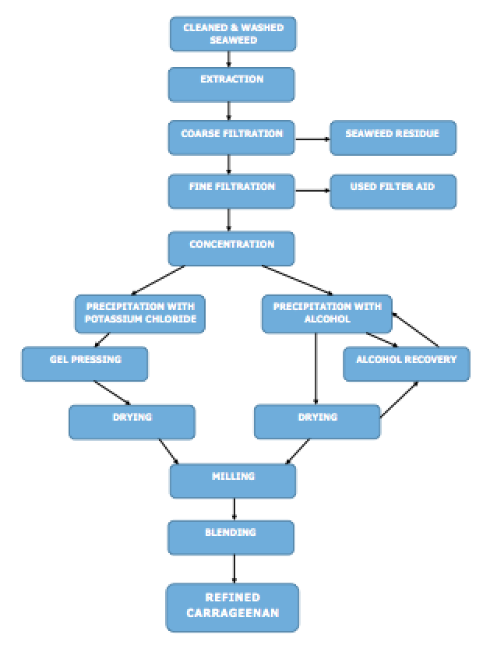
Source: FAO

Figure 1. Flow chart on refined carrageenan processes

- Semi-refined carrageenan (SRC), seaweed flour- In SRC, there is no process of extraction of kappa-carrageenan from seaweeds.
- Philippine Natural Grade (PNG) - the process for PNG is a variation of processed used in SRC. After harvest and washing, seaweeds are chopped and bleached.
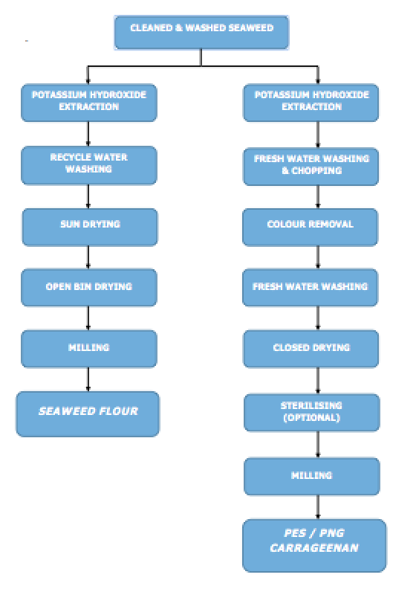
Source: FAO
Figure 2. Flow Chart of Production of Semi Refined Carrageenan and PNG

- Alkali Treated Chips (ATC) - This product form use alkaline treatment in processing dried seaweeds. By using ATC, gel-forming properties of carrageenan can be improved.

- Industry Uses

- Dairy Products
- Cottage Cheese and Ice cream- Carrageenan when included in the mixture of cottage cheese and ice cream can be an agent in avoiding Whey separation, which makes its quality better. 0.01-0.04% of carrageenan must be used to be effective.
- Instant chocolate mix and cocoa in chocolate milk- carrageenan can be used as a suspender in instant chocolate mix and it can be used to give the desired mouth feel to the product. Carrageenan is used as agent in keeping the suspension of the mixture of chocolate milk
- Whitener liquid coffee and evaporated milk- Carrageenan can also be used as an instrument in whitener in liquid coffee and evaporated milk as it can prevent the separation of fats in the mixture.
- Natural Cream- Natural cream can greatly benefit from carrageenan because it helps in keeping the cream’s color and appearance intact when whipped.

- Water Based Products
- Fruit Jellies and sorbet- Carrageenan can be used as a substitute for pectin in fruit jellies and as an alternative in non-fat ice cream.
- Salad dressings- Salad dressings use carrageenan as suspenders of its herbs and it can be used to give mouth feel to its properties.

- Meat Products
- Ham preparation- Carrageenan, when mixed with brine solution, can aide in retaining soluble protein in ham preparation. It can also be used as binder.
- Pre-cooked poultry products- farmers have been using carrageenan in preparing precooked poultry products. Carrageenan, also when mixed with brine solution with salt and phosphate, is being injected to chicken and it can act as water binder within the muscle of the chicken. The solution can also improve the quality, tenderness and texture of the product.

- Pet Food
- Seaweeds can be used as seaweed flour or seaweed meal, which can be fed to animals. Seaweeds can be milled to fine powder or be fed as freshly cut.

- Other Uses
- Fertilizer
- Soil Conditioner
- Toothpaste
- Biomass Fuel
- Air freshener gels
- Soap
- Shampoo
There are two major processors of seaweeds in CALABARZON namely: W. Hydrocolloids and Philippine Bio Industries. These companies process raw dried seaweeds with different signature activities to produce their final product of Semi-refined Carrageenan or Carrageenan powder, which are exported to different countries in Asia especially in China, Japan and Korea. The exported Semi-refined Carrageenan and Carrageenan powder from these processors are being used by many countries as binders, substitutes, suspenders and other functions.
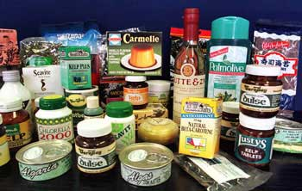



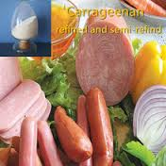



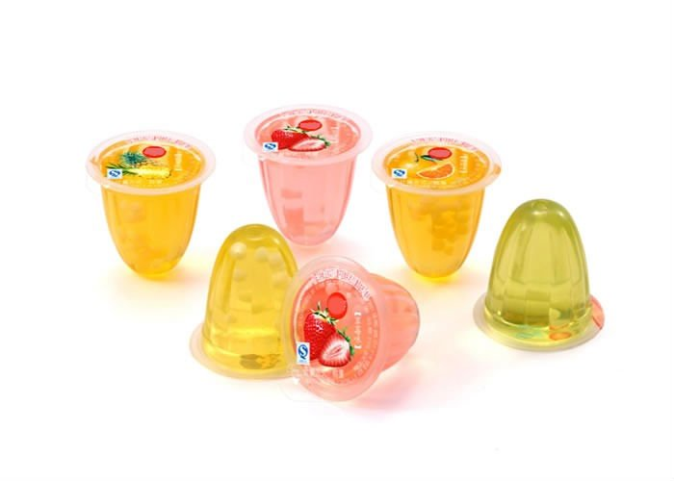

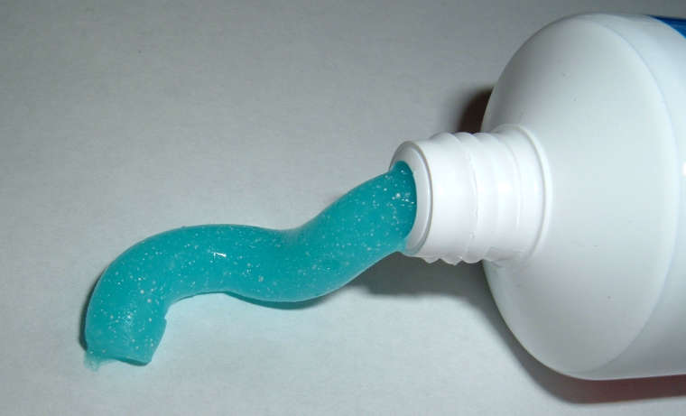

Source of Photos: Google.com
- Production Trends

- Global Production
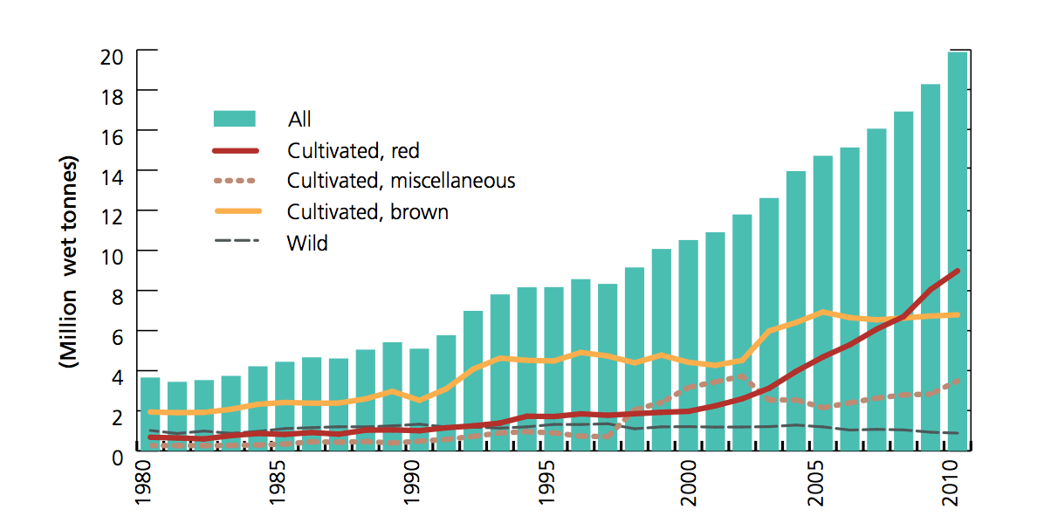Source: FAOSTAT
Figure 3. World Seaweed Production, 1980-2010

It can be observed from Figure 3 the increase in world production of seaweeds from 1980 to 2010. World production of seaweeds rose from less than 4 million MT in 1980 to almost 20 million in 2010. It can be attributed to the increasing demand for seaweeds with applications such as food additives, binders, feeds, pharmaceutical, cosmetics and others. According to FAO statistics, the source of seaweeds produced has shifted from wild to cultivated seaweeds which is supported by the figure above that percent share of seaweed from the wild has decreased from 28% in 1980 to 4% in 2010. Seaweed farmers started cultivating brown seaweeds more than red and other types of seaweeds but cultivated red seaweeds have emerged as the top produced seaweed with 2 million MT to almost 9 million MT from 2000 to 2010. It has a percentage share of 21% in 1980 and increased to 47 % in 2010. (FAOSTAT)
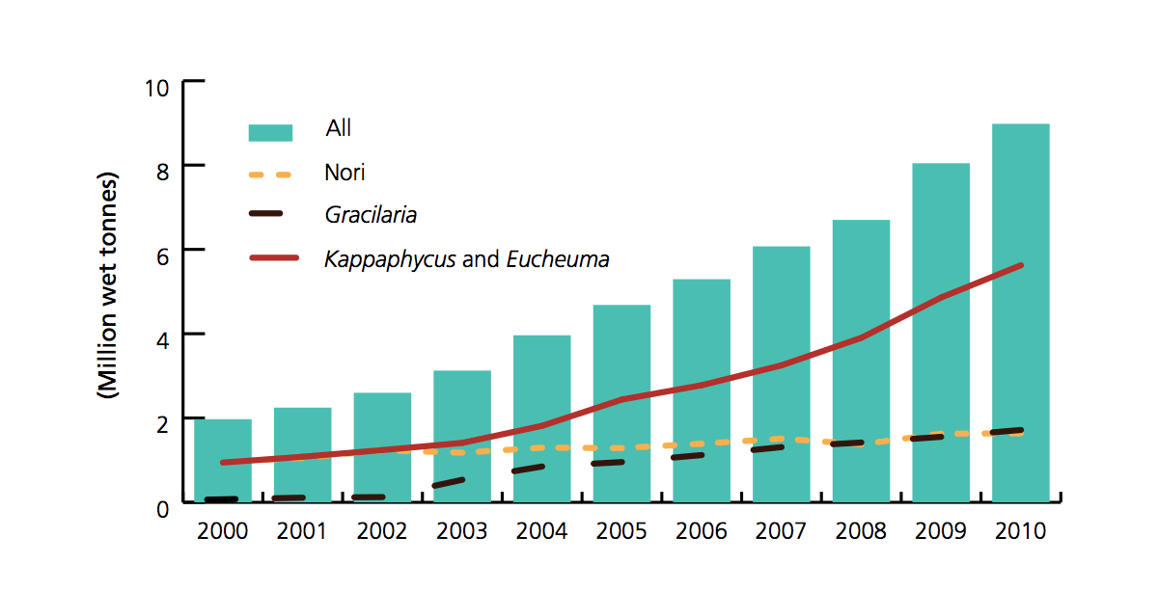
Source: FAOSTAT

Figure 4. World Red Seaweed Farming Production, 2000-2010

Figure 4 shows that red seaweeds production started with Kappaphycus and Eucheuma as source of carrageenan and gracilaria as source of agar but later on comes the discovery and production of Nori which is a type of red seaweeds used in food consumption. Also, Kappaphycus and Eucheuma has the most volume produced for the year 2000-2010 with 1 million MT to 6 million MT respectively which is caused by the expanding demand of carrageenan by the world market. Second in production volume is the gracilaria followed by Nori. It can also be observed that production has increased for all the types of red seaweeds.

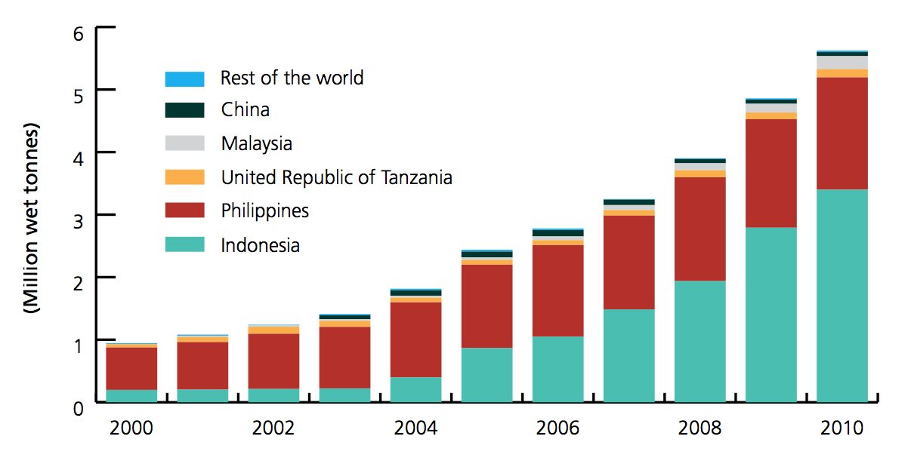
Source: FAOSTAT

Figure 5. World Carrageenan Seaweeds Farming Production, 2000-2010

Figure 5 illustrates the major seaweed producing countries together with its volume of production and it can be observed that there are two countries which dominate the production of seaweeds namely: Philippines and Indonesia.

Indonesia currently leads the world in carrageenan seaweed production with 61 percent share in world production for 2010. Based from the table, Philippines formerly leads the world production of carrageenan seaweeds in 2000 with 72% percent share and Kappaphycus as the main species being cultivated but has declined in years with Indonesia rapidly maximizing its production of Kappaphycus alvarezii. Philippines currently have 32% of the production of carrageenan seaweeds in 2010 and together with Indonesia account for 90% of the global production of carrageenan seaweeds.

Other major producing countries include China, Malaysia and United Republic of Tanzania with the remaining 10 percent of the carrageenan seaweed production.

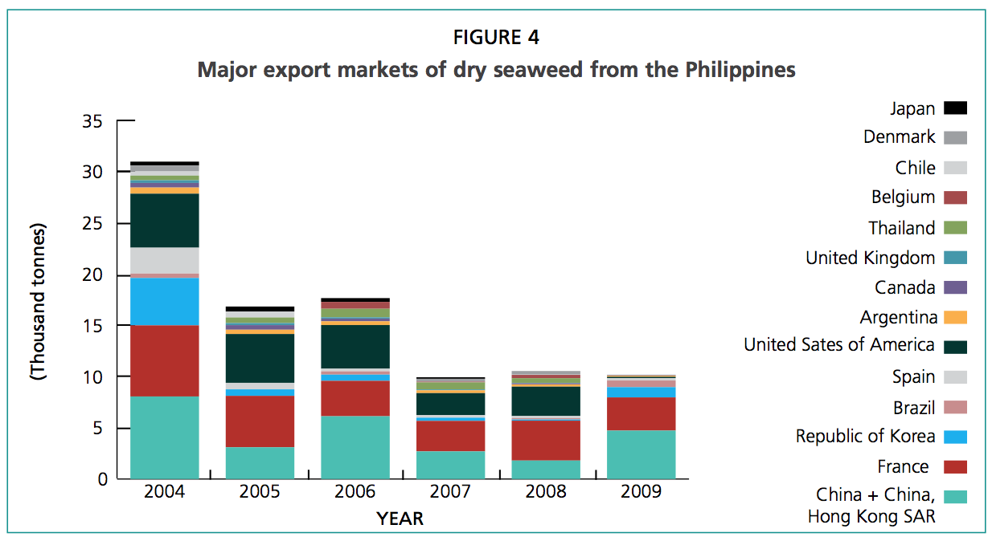Source: FAOSTAT
Figure 6. Major Export Markets of Dry Seaweed from the Philippines, 2004-2009
As shown in Figure 6, Philippines have also been exporting Raw Dried Seaweeds (RDS) by means of trading posts and other exporters. There are trading posts, which export their seaweeds commodity directly without going into processors because export market for RDS have their own specifications for carrageenan extraction and carrageenan processing. The major export market for RDS include China, France United States of America and Korea, which dominate the export market.

Table 1. Major Markets for Seaweed Exports from Indonesia, the Philippines, and the United Republic of Tanzania, 2011
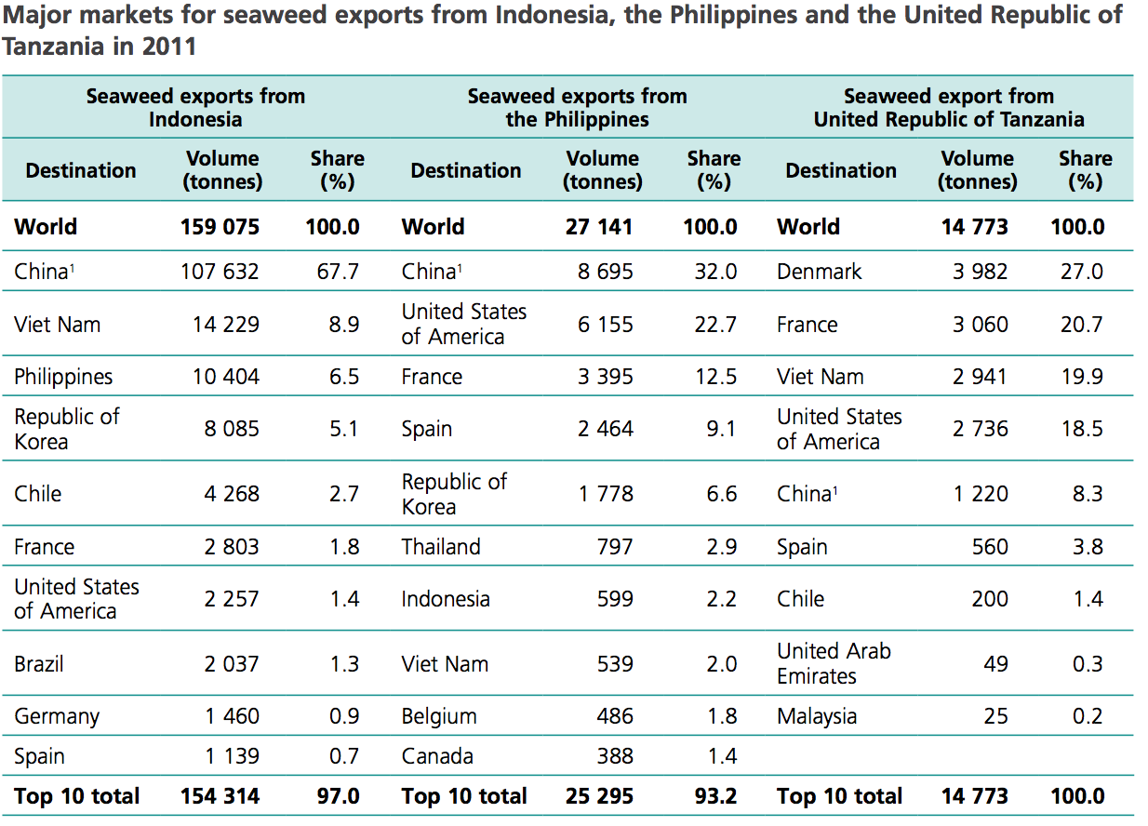
Source: FAOSTAT
Table 1 exhibits the major markets for seaweed exports from Indonesia, Philippines and the United Republic of Tanzania in 2011 and it can be observed that seaweed exports from the Philippines is relatively low compared to Indonesia but higher than the seaweed exports of United Republic of Tanzania. Also, the main market of the Philippines for seaweed exports is China with 8,695 tons of seaweed being exported from the Philippines and 32% share in export market of the Philippines. United States of America and France are second and third in percent share of seaweed exports of the Philippines in 2011 with 22.7 % and 12.5%, respectively. Other export market include Belgium and Canada with 486 and 388 tons of seaweed exports from the Philippines, respectively.

Table 2. Dried Seaweeds Production (in MT) and Average Growth Rate (%) in the Philippines, by island, 2010-2014
 | 2010 | 2011 | 2012 | 2013 | 2014 | Average Production | Growth Rate
Luzon | 565,017.07 | 591,648.75 | 567,565.39 | 447,272.97 | 456,764.76 | 525,653.79 | -19%
Visayas | 222,674.86 | 242,676.10 | 242,043.62 | 217,305.45 | 200,336.24 | 225,007.25 | -10%
Mindanao | 1,013,579.66 | 1,006,508.01 | 941,461.61 | 893,799.32 | 892,474.98 | 949,564.72 | -11%
Source: PSA-BAS
Table 2 shows the domestic production of seaweeds for Luzon, Visayas and Mindanao from 2010 to 2014 and it shows that Mindanao has the largest volume of production with an average production of 949,564.72 MT followed by Luzon with an average production of 525,653.79 MT and Visayas with average production of 225,007.25 MT. Mindanao’s seaweed production accounts for 56% of total production, 31% for Luzon’s production and the remaining 13% for the production of Visayas. Also, Luzon has a negative growth rate of 19%, Visayas with negative 10% and Mindanao with negative 11 % growth rate.

Table 3. Dried Seaweeds Production in the Philippines, by region, 2010-2014
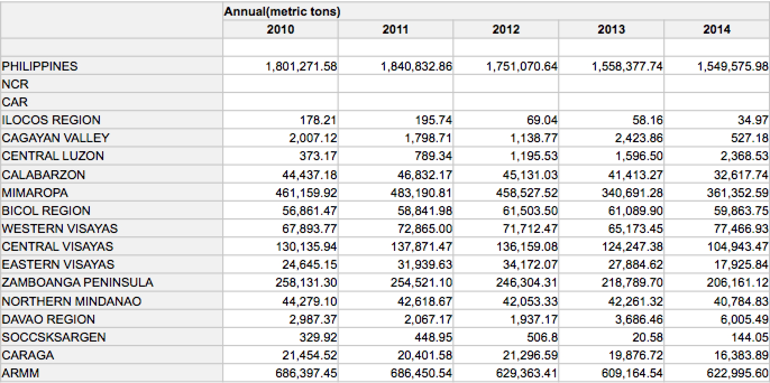
Source: PSA-BAS
Table 3 shows that total domestic production of seaweeds of the Philippines has gradually decreased from 2010-2014. It has a total production of 1.8 million MT in 2010 but has decreased its production for the following years with 1.55 Million MT in 2014. Decrease in production can be explained by the calamities that hit our country that washes out the seaweed farming areas and farming systems of the country. Most farmers use bamboo and ropes in their farming thus heavy rainfall can cause destruction of farming systems. Also, seaweed diseases and fishes eating their seaweeds in the farming area also contribute to decrease in production.

ARMM is the top seaweed-producing region from 2010-2014 with an average production of 646,874 MT followed by MIMAROPA with an average production of 420,984.42 MT and Zamboanga Peninsula with an average production of 236,781.51 MT. CALABARZON rank 8th on seaweed production with an average of 42,086.28 MT and a 2014 production of 32,617.74 MT.

Table 4. Top Average Seaweeds Producers in the Philippines, per province, 2010-2014
PROVINCE | PRODUCTION
Palawan | 414,824.38
Tawi-tawi | 333,505.41
Sulu | 218,139.30
Bohol | 117,336.73
Zamboanga Sibugay | 110,866.95
Maguindanao | 88,867.49
Antique | 69,721.98
Zamboanga City | 57,823.46
Quezon | 41,171.43
Zamboanga del Norte | 36,212.372
Source: PSA-BAS

Although CALABARZON ranks 8th in production of seaweeds in the Philippines, it is worth noting that it is still a major producer of seaweeds with Quezon ranking 9th in the average production of seaweeds per province in the whole Philippines with 41,171.43 MT.

Table 5. CALABARZON Seaweeds Production (in MT), per Province, 2010-2014
PROVINCE | 2010 | 2011 | 2012 | 2013 | 2014
Cavite | - | - | - | - | -
Laguna | - | - | - | - | -
Batangas | 1,450.55 | 1,370.47 | 547.86 | 1013.13 | 192.31
Quezon | 59,580.9 | 42,986.62 | 45,461.7 | 40,400.24 | 32,425.43
Rizal | - | - | - | - | -

Based from the figure above, it can be observed that there are only two provinces in CALABARZON which produce seaweeds: Quezon and Batangas. Quezon Province has the majority of the production with an average production of 41,171.43 MT and an average percent share of 97.9% in the production of seaweeds in CALABARZON while Batangas has an average production of 997.37 MT and an average percent share of 2.08 % in CALABARZON seaweed production. Although CALABARZON ranks 8th in production of seaweeds in the Philippines, It is worth noting that it is still a major producer of seaweeds with Quezon ranking 9th in the production of seaweeds per province in the whole Philippines with 41,171.43 MT.

Source: Quezon Provincial Agriculturist Office
Figure 7. Seaweed Production in CALABARZON, 2014

As shown in the figure above, there are only two provinces that can produce seaweeds in CALABARZON. According to BFAR, Cavite, Laguna and Rizal were not able to cultivate seaweeds in their province because their coastal areas were not suitable for seaweeds production. Even Batangas only has one Municipality (Calatagan) that can cultivate seaweeds but their production is catching up with already four seaweed producing barangays and 2 barangays being developed for production. Calatagan has a production of 752 MT in 2014, which is 3rd in total production in CALABARZON.

Quezon province has most of the production of seaweeds in CALABARZON with Calauag as the top-producing municipality at 1,477 MT. It can be observed that island municipalities produce higher volume of seaweeds compared to other municipalities with Jomalig, Panukulan, Polillio, Burdeos and Patnanungan taking the bulk of CALABARZON’s production.

Table 6. Profile of seaweed farmers of CALABARZON per municipality, 2014
Municipality | No. Of Farmers | Production (MT) | Area (hectares)
Jomalig | 70 | 609.7 | 23
Patnanungan | 121 | 999.2 | 22
Panukulan | 120 | 467.1 | 22.60
Polillo | 20 | 423.2 | 18.5
Burdeos | 132 | 632.5 | 33
Mauban | 45 | 2 | 1.7
Padre Burgos | 25 | 51 | 1.5
Agdangan | 204 | 3.2 | 45
Pitogo | 30 | 8.4 | 1.0
Calauag | 402 | 1,477 | 276.25
Calatagan | 147 | 752 | 30
Source: Office of the Provincial Agriculturist (Quezon and Batangas)

As shown in Table 6, Calauag has the highest production area, number of farmers and production volume for all the municipalities in CALABARZON, which shows that seaweed farming in Calauag is one of the main sources of income for residents nearby the coastal areas. Next in production volume is Calatagan, Patnanungan, Burdeos, Jomalig, Panukulan, Polillo with their production more than 400 metric tons annually in 2014. Pitogo, Agdangan, Padre Burgos and Mauban are included in the municipalities with lower production. The scenario may be explained by island municipalities focusing their livelihood on seaweed farming due to their location while municipalities in the center of trade focusing their livelihood in many ways. Seaweed farmers also mentioned during our focus group discussion that they are thinking about going inactive in seaweed production due to typhoons washing out their seaweed farming area, which results to losses.

SECTION 3: Nature and Structure of the Industry

- Value Chain Mapping
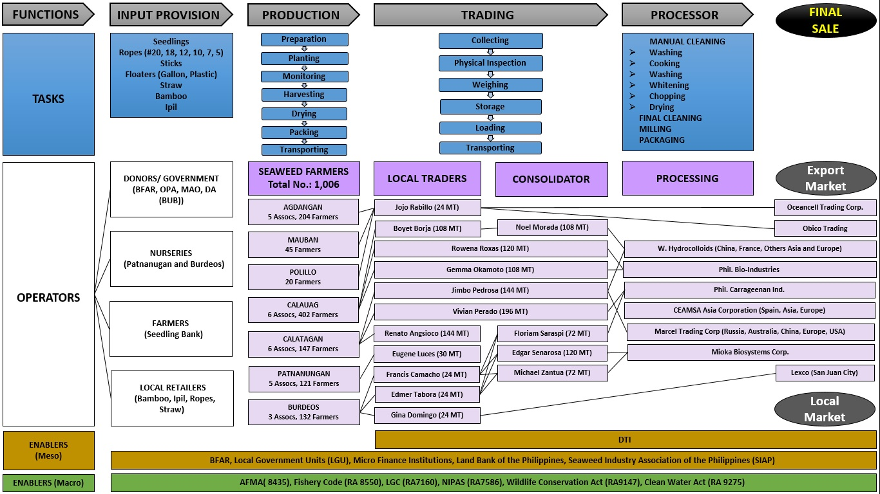
Figure 8. Seaweed Value Chain Map of CALABARZON, 2014
- Value Chain Players And Their Functions

The segments along the value chain are identified by players or sectors with their minimum functions.

- Input Suppliers
Input suppliers are considered to be the starting point of the Value Chain Analysis because farmers rely heavily on input suppliers for their raw material inputs like seedlings, bamboo, ropes, floaters, nets and others. Seaweed farmers cannot start their production cycle without raw material inputs.
Input suppliers include Local Government Units (LGUs), Municipal Agriculturist Office (MAO), Private entities like farmer seedling bank and commercial stores. LGU and MAO provide support in terms of giving private nurseries, seedling and other farming materials to farmers associations. On the other hand, Private seedling banks are available for fresh seaweed purchase whenever there are no supply from the government and commercial stores provide seaweed farmers good quality materials.

Table 7. Input Suppliers in Seaweeds Farming
Input Supplier | Details
BFAR | DA–BFAR IV(A) Freshwater Fisheries Technology Outreach Station (FFTOS)  Bambang, Los Banos, Laguna  Regional Fisheries Office No. IV-A (CALABARZON)  2/F Infrastructure Computer Center  (ICC) Bldg., NIA Complex, EDSA  1104 Diliman, Quezon City  Seaweed farmers are supported by the DA-BFAR. BFAR provides grants of seedlings, ropes and straws. They give seminars, trainings and workshop to the farmers on production development.
MAO/LGUs | MAOs with their LGUs are supporting the seaweed farmers by giving trainings and seminars on association/cooperative management and seaweeds’ productiveness. They also provide grants of ropes, straws, small boats and gasoline for farming maintenance. The MAO involved include MAO Senen Tamesis of Padre Burgos, MAO Perciveranda Galang of Unisan, MAO Joemar Salagubang of Agdangan, MAO Nelida Lagmay of Pitogo, MAO Euguene Luces of Patnanungan, MAO Milagros A. Lalaguna of Pollilio, MAO Delfin Del Rio of Panukulan, MAO Elizabeth Eyatid of Jomalig, MAO Luz Rosas of Calauag, MAO Ma. Evelyn Custodio of Calatagan and the president of MAOs in quezon MAO Petronilo Abuyan of Mauban.
Seedling Banks/Co-Farmer | Farmers of the same association lend or sell fresh seaweeds to their colleagues in the association when they have extra supply of fresh seaweeds.

- Seaweed Farmers
Seaweed Farmers in CALABARZON are usually organized in a seaweed farmer association for their respective barangays and they often have a system of farming which is patterned with their municipality. For CALABARZON, there are a total of 1,006 farmers in CALABARZON, which are divided into different Seaweed Farmers Association. There are a total of 25 active farmers and a lot of inactive farmers due to threat of typhoon and devastation of their farming area. Most of the seaweed farmers rely on input suppliers for farming materials and they practice fresh seaweed stocking which they will use as input for the next cycle. The seaweed farmers profile is for CALABARZON is presented below.

Table 8. Profile of Seaweed Farmers Association, Location, and Description
Farmers Association | Location | Description
- Womens Seaweeds Farmer Association-(15 farmers)  - Gulod Seaweed Farmer Association-(1)  - Bukal Seaweed Farmer Association  - United Aquaculture of Poblacion IV.  - Layon Carbonan seaweeds farmer  - Samahan ng maliliit na seaweeds farmer ng Barangay Uno | Calatagan | Total Farmers- 147  Total production in 2014- 752MT.  Production system-mainline/straightline and tulos method.  Final product- Fresh seaweeds and Raw dried seaweeds.  Constraints in farming include-stealing of seaweeds, fluctuating selling price, insufficient supply of materials, area conflict and pricing coordination
- Samahan ng Maliliit na mangingisda ng villa san isidro  - Samahan ng Maliliit na mangingisda ng laing laingan  - Samahan ng Mangugulaman ng Tamis  - Samahan ng Maliliit na mangingisda ng Santo Anghel  - Pagibayuhin ang lakas ng Anak Dagat. (PALAD)  - Samahan ng KISLAP kababaihan ng Pinagsakayan | Calauag | Total Farmers-402.  Total Production in 2014-1,477MT.  Production system-mainline method.  Final Product- Raw Dried Seaweeds.  Constraints in farming- Calamity, low buying price of traders, Diseases, market rivalry, lack of materials for farming (ropes, seedlings, boat, drying facility), farm to market road.
- Samahan ng Maliliit na mangingisda ng calutcot  - Samahan ng mangingisda ng Palasan  - Samahan ng Mangingisda ng Carlagan | Burdeos | Total Farmers-132  Total Production in 2014-739 MT.  Production System-Mainline method.  Final Product- Fresh seaweeds and Raw dried seaweeds.  Constraints-Calamities, diseases, Insufficient supply of seedlings and materials, low capital, unstable price. Boat and drying facility.
- Bisig mangingisda ng sildura  - Samahan ng mangingisda ng dinagdag  - Samahan ng mangingisda ng kanlurang calutan  - Samahan ng mangingisda ng silangang calutan  - Samahan ng Mangingisda ng Salvacion | Agdangan | Total Farmers-204  Total Production in 2014-4MT  Production system-Mainline/Straight line method.  Final Product- Raw Dried Seaweeds.  Constraints-Calamities, Sea turtles, danggit, diseases, illegal fishing, cyanide, low market
- Seaweeds Association of Patnanungan  - Samahan ng Magsiseaweeds ng barangay norte  - Kilogan Seaweed farmers  - Kababaihan Seaweed planters  - Seaweed planters and fish cage association | Patnanungan | Total Farmers-121  Total Production in 2014- 990 MT  Production system- Mainline/straightline method  Final Product- Raw dried seaweeds  Constraints- Pest and diseases, cyanide, decrease in production. Some of the associations of Patnanungan are inactive due to typhoons washing out their seaweeds.

- Traders

The traders are the one who give link to the processors. Traders always monitor the market trend of seaweeds depending on the demand of the processors. They have the ability to negotiate between the processors and seaweed farmers in the ground. Some traders establish their own buyers abroad and play as exporter. They ship RDS of about 20 MT – 40 MT/container. Traders have established its own barangay traders and local traders to sustain their sources and suppliers.
- Local Traders
Local traders are directly involved with farmers as they are the link of farmers from barangay and municipalities. There are local traders who are also farmers and most of the time local farmers are common to fishermen as they live in the same community. They also play as creditors/financiers to sustain the seaweed farmers’ production. They lend money to the seaweed farmers with no interest but in return, the harvested seaweeds will be delivered to them. They have seaweed warehouse facilities for stocking and they hire truck/jeepney to transport the seaweeds to big traders/consolidators. Local farmers commonly deliver 3-4 MT Dried Seaweeds to the consolidator after 45 days.
- Big Traders/Consolidator
Big Traders for seaweed industry are traders that possess a big capital for the business unlike local traders wherein they can only buy seaweeds from farmers if they have enough capital. Big traders are known by local traders because there are instances wherein they bring their seaweeds collected to big traders within the area. This situation can help the local traders to lessen their transportation cost and truck/jeepney rental. Big traders deliver their collected seaweeds to trading post or to processors, which have been their contact and partner in the industry for a long time. The capacity of the consolidators in terms of seaweed buying can range from 72 MT to 200 MT dried seaweeds annualy. There are consolidators, which assign a local trader in one area to secure seaweed collection. Consolidators also transfer from one processor/trading post to another whichever has the higher buying price. Big traders usually own a 20-footer truck for transport and delivery, which has the capacity to load 12-15MT of dried seaweeds per delivery. Some of the consolidators also serve as the local trader for their area. According to some consolidators that were interviewed, the seaweeds that they have collected were brought to some trading post or “bagsakan” that can be located in areas such as Food Terminal Incorporated (FTI) in Taguig, Binondo, divisoria and others. These trading posts are commonly owned by chinese businessmen and some consolidators assumed that they export the seaweeds that they buy from them.
During the Focus Group Discussion conducted in Ouans’ Worth Farm and Resort, Lucena City and Interviews with farmers and local traders, it has been traced that Seaweed production in 2014 has been very abundant compared to production in 2015. The seaweed production in 2014 as recorded by the Bureau of Agricultural Statistics is 32, 617 MT Dried seaweeds but destructive typhoons and seaweed diseases have greatly affected production and seaweed farming which resulted to extremely large amount of losses in production. The farmers added that they were not able to grow seaweeds because it is being washed out by heavy rains and seaweed diseases. Based on the interviews made from local traders and consolidators, we were able to trace 1, 138 MT of dried seaweeds sold to traders.

Table 9. List of Local Traders, Big Traders/Consolidators, and Training Post/Processors
LOCAL TRADERS | BIG TRADERS/  CONSOLIDATORS | TRADING POST/ PROCESSORS
Jojo Rabillo  Unisan, Agdangan, Pitogo, Padre Burgos.  (24 MT Annually) |  | Oceancell Trading International Corp. (Binondo)  Obico Trading
Francis Camacho  Burdeos, Patnanungan | Edgar Senarosa (120 MT) | Lexco Warehouse (San Juan)
Edmer Tabora  Burdeos, Patnanungan | Floriam Saraspi (72 MT) | Mioka Biosystems Corp. (Canlubang)
Gina Domingo  Burdeos | Michael Zantua (72 MT) | Marcel Trading Corp.
Eugene Luces  Patnanungan |  | W. Hydrocolloids
Calatagan Farmers | Jimbo Pedrosa (144 MT) | Philippine Bio Industries
 | Vivian Perado (196 MT)
 | Renato Angsioco (144 MT)
Calauag Farmers | Noel Morada (108 MT) | Export Countries
Boyet Borja  (108 MT annually) | Gemma Okamoto (108 MT)
 | Rowena Roxas (120 MT)

Trader’s Operation
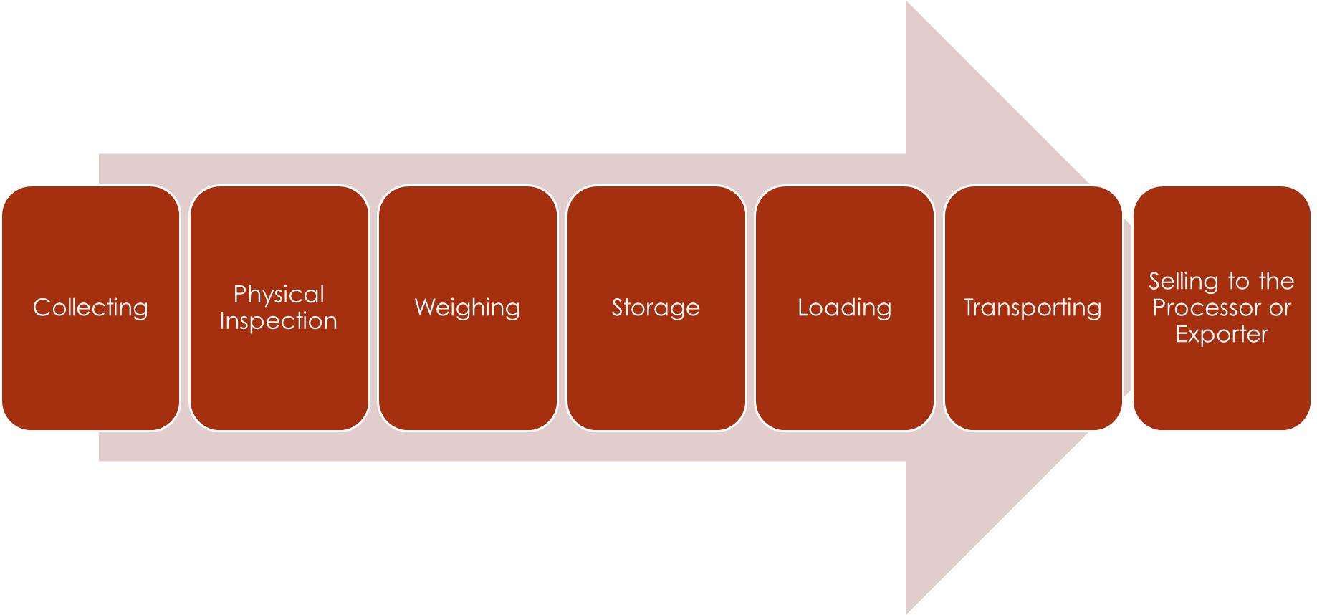
Figure 9. Trader’s Operation

- Processors/Exporters

Processors have links between multinational companies abroad and traders in the country. The RDS which was given to them by their respective traders from various provinces are being processed in their plant and have a finished product of Carrageenan. Each seaweed processor gets with a minimum of 6,000 MT per year nationwide.
They preferred seaweeds in the South most area of the country, such as, Palawan, Cebu, Zamboanga, and Tawi-Tawi but Quezon and Batangas are consider as their regular suppliers with a minimal volume of production. After the traders transported the seaweeds in their processing plants, they conduct the procedure of washing, drying, grinding and make it to powdered form (Carrageenan). They follow the steps of First In, First Out (FI, FO) process and monitor the market trends of seaweeds on a weekly basis.

Process Flow in Seaweeds Production
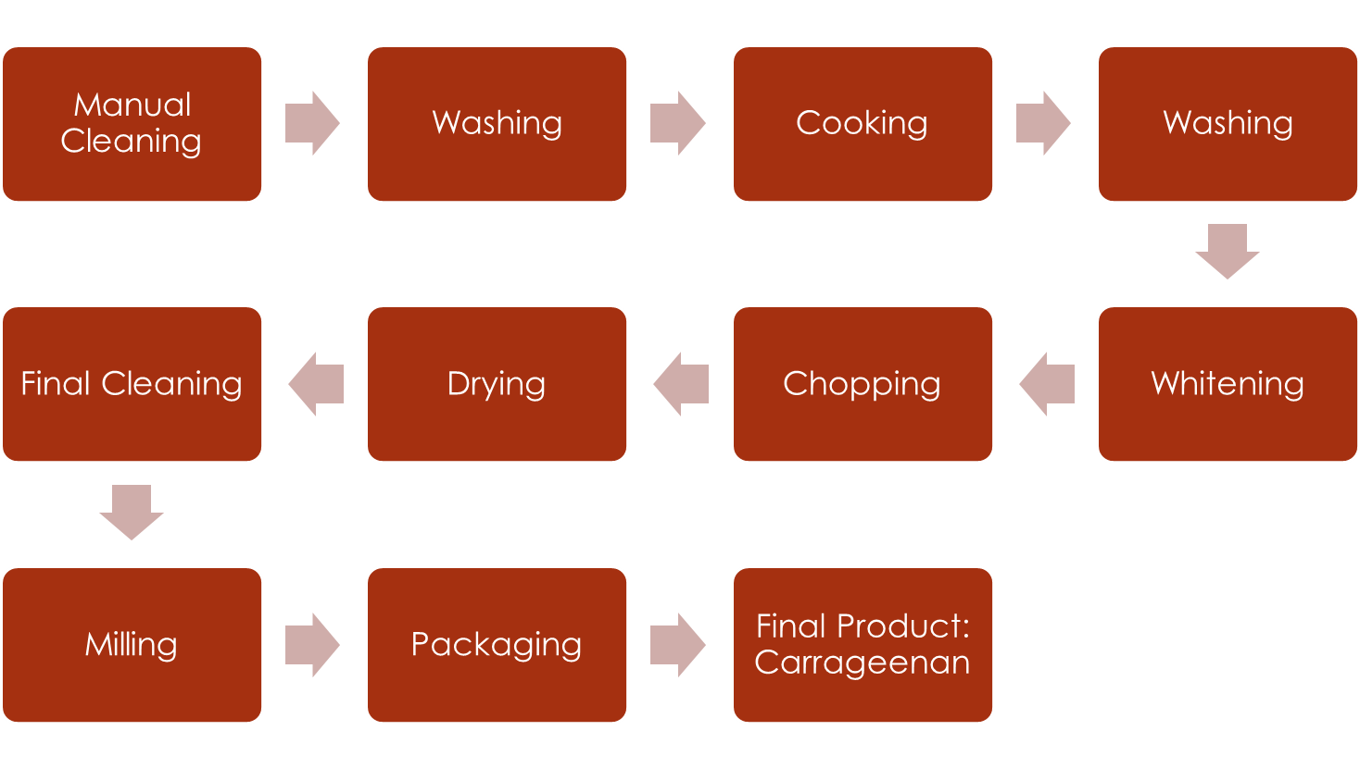
Figure 10. Process Flow of Seaweed Production

Table 10. List of Processors, Capacity/Volume and Source per Month, Product and Market
Processor | Capacity/Volume and Source per month | Product | Market
W. Hydrocolloids | 500 MT Calatagan Batangas, Quezon, Bicol, Zamboanga, Tawi Tawi, Palawan | Rico Carrageenan. Food grade and non-food grade carrageenan | China, France, Other countries in Asia and Europe
Marcel Trading Corporporation | 10-20MT/per month each from Calatagan Batangas, Zamboanga and Palawan | Semi-refined carrageenan, Carrageenan powder | Russia, Australia, China, Europe, USA
Ceamsa Asia Corporation | 300MT from Zamboanga, Tawi-Tawi, Palawan. | Semi refined Carrageenan, Refined Carrageenan | Spain, Asia, Europe
Philippine Bio Industries
(no available data)
Mioka Biosystems Corporation
(No available data)

- Seaweed Processors in CALABARZON

- CARGILL FRANCE SAS
(Lifted from Cargill website)

Cargill provides food, agriculture, financial and industrial products and services to the world. Together with farmers, customers, governments and communities, we help people thrive by applying our insights and 150 years of experience. We have 152,000 employees in 67 countries that are committed to feeding the world in a responsible way, reducing environmental impact and improving the communities where we live and work. Agricultural commodity trading & processing. We connect producers and users of grain, oilseeds and other agricultural commodities through origination, processing, marketing and distribution capabilities and services.

- CEAMSA Asia Inc.
(Lifted from CEAMSA Asia Inc. website)
Founded in 1967, Compañía Española de Algas Marinas S.A., CEAMSA, manufactures and supplies a comprehensive range of high quality carrageenan and pectin products to the global food industry. In February 2009, CEAMSA Asia Inc. was incorporated and registered in the Philippines to be the first international venture of CEAMSA. Our company is 99.99% owned by CEAMSA Spain. We are a semi-refined carrageenan manufacturing plant that utilizes technology developed by our parent company. Our products are 100% percent export. In addition, as an export oriented firm, CEAMSA ASIA INC. is a bonafide Board of Investment registered enterprise. Our plant is located in Pook Looban 2 Crispulo dela Cruz St, Loma de Gato Marilao, Bulacan, Philippines.

- MARCEL TRADING CORPORATION
(Joint venture with Philippines Bio Industries)

Marcel Trading Corporation started business in 1969, exporting various sea products. In 1971, Marcel added dried seaweeds to its range of exports. Because of its policy of strict quality control and good value, the company quickly established strong supply relationships with many Carrageenan processors worldwide. As a major supplier of dried seaweed to the Carrageenan Industry, Marcel had been extensively involved in seaweed farming activities, which in turn has helped provide livelihood for hundreds of farmers and spur economic growth in seaweed farming areas in the Philippines.

- W. HYDROCOLLOIDS CORPORATION

W. Hydrocolloids, formerly known as PCI (Philippine Carrageenan Industries) Worldwide, is a seaweed processing company with its head office located at Bonifacio Global City and its plant located at Carmona, Cavite. W. Hydrocolloids was established in 2003 and since then became one of the worldwide leaders in Carrageenan production with Rico Carrageenan as their banner product.
W. Hydrocolloid aims to be the worldwide leader in food ingredients solutions. It is still innovating and finding ways to capture bigger market and produce carrageenan products, which can answer to customer’s demands that is why they have established a research laboratory for further discoveries of new product lines.

- MIOKA BIOSYSTEMS CORP.

Mioka Biosystems Corporation (MIOKA) is a manufacturer and supplier in Canlubang, which specializes in world-class food grade Carrageenan. It is the first have an ISO 9001: 2008 Quality Management System and ISO 22000: 2005 Food Safety Management System certifications. Its farming site is located in Zamboanga, Philippines and its manufacturing plant is located in Canlubang Laguna. Mioka ensures quality in its products from farmer to customer by securing its proximity to its stakeholders. Mioka provides value to its customers by customizing its Carrageenan products depending on customer’s preference. They work with their customers to develop the best possible functional Carrageenan system for their products. Mioka manufactures semi refined food grade Carrageenan using the best technology platforms. Its company production and quality control personnel are committed to providing consistent quality products to the market.

- Seaweed Exporters

Table 11. Export Data of Seaweeds for 2014 (CALABARZON)
EXPORTER | CONTACT NO. | QUANTITY (kg) | VALUE ($)
EXPORTER | CONTACT NO. | 2014
Ceamsa Asia Inc. | 242-28-82 | 1,298,560.00 | 7,784,810.00
Lexco Int'l. Trdg | 722-16-55 | 1,500.00 | 2,250.00
Marcel Trdg. Corp. | 559-9098/712-1989 | 14.00 | 19.50
Mioka Biosystems Corp
Obico Marine PROD | 417-38-13/502-28-70 | 7,552.40 | 2,563.75
Ocean Aquamarine Prod | 242-81-64/242-81-75
Ocean Square Marine Prods.
Oceancell Trdg. Int'l. Corp. | 870-21-16/242-30-65 | 10,800.00 | 19,440.00
PCI Worwide Inc.
W Hydrocolloids Inc |  | 221,993.62 | 243,366.25
Source: DTI

- Nature of Interfirm Relationships

- Horizontal Analysis

Stakeholders in the seaweed industry form association/cooperative that can help them in their certain segments/level. Input suppliers include BFAR, DTI, and BUB projects of Department of Agriculture and they are somehow interrelated with each other in terms of how they function as a government entity and their objective to help farmers with input provision. Some of the inputs that are provided include seedlings, ropes, sticks, nets and others.
Seaweed farmer’s association is commonly organized among farmers within the area or barangay. They have a structure like a common organization with president, vice president and secretary. The president of the association represents the whole body whenever there are meetings, seminars, and convention, which are helpful to farmers. Seaweed Farmer Association is also assembled to properly facilitate the distribution of seedlings and other farming inputs, seminars provided, other government support services extended to farmers by different government agencies although not all of the farmers within the barangay are able to receive the help given from the projects. Farmers who were not able to receive seedlings resort to buying from their co-farmer within the association whoever has some extra kilograms of seedlings in their inventory. There are few farmers who really produce fresh seaweeds for their co-farmers as input provision and they are called seedling banks.
Seaweed farmer’s association is also created to share information like the prices from different traders and who buys higher, quality requirement of the traders and other news which concerns the seaweed farmers within the area. Some of the association consolidate their harvest for one cycle and sell it to one trader while other associations sell to different traders on their own. They usually hire a jeepney or a small truck and load the harvest of the whole association and deliver it to the local trader.
Some of the traders in CALABARZON join the Seaweed Industry Association of the Philippines (SIAP) and others run their business on their own. In one area, there are several traders that can buy the harvest of the farmers. Traders differ in buying price of seaweeds but they tend to keep it regulated to keep their credibility and avoid the interference of the local government unit or the municipality mayor. Traders also differ in levels depending on their capacity to buy seaweeds namely: local trader, big trader and trading centers. Some of the local traders sell to big traders and trading centers as to big traders selling to trading centers.
Most of the Seaweed Processors are members of the SIAP but they tend to keep their information confidential to each other. There are processors in the Philippines that have arranged a joint venture among them like Cargill Inc. and Philippine Bio Industries to improve market share. The world market for seaweeds regulates prices in the processor’s side. Also, prices depend on their cost for processing raw dried seaweeds to final product of powdered carrageenan.

- Vertical Analysis

The relationships between the input suppliers to farmers, farmers to traders, traders to processors and processors to exporters or export market are evident in the structure of the value chain analysis for seaweeds. The seaweed industry will not move and grow if the relationship between stakeholders is not well established.
Seaweed Industry Association of the Philippines (SIAP) is an association involving farmers associations, traders, processors and exporters and it assists every member of the association in marketing their product, regulating price in the market and promoting seaweed production in the country. Also, SIAP helps in monitoring the quality of the seaweed products and in disseminating the seedlings to farmers.
The input suppliers like BFAR, DTI and other LGUs carry out their seedling disbursement program by using seedling farmers associations as a channel for the seedlings to reach the seaweed farmers. The farmers on the other hand can communicate with the input suppliers for their other needs like seminars and financial matters which then will be forwarded to other support giving bodies.
Nowadays farmers and traders build a good business relationship because they need each other for their income and livelihood to develop. Farmers sell their harvest to several local traders, whoever has the best buying price, and farmers do their best to keep their harvest at best quality. In return, the traders tend to give the farmers reasonable and competitive buying price to keep the trade fair and other traders give a little extra help to the farmers by giving some farming materials. There also exist a credit system between farmers and traders wherein the traders pay the farmers in advance before the delivery of the harvest as a form of credit. This kind of scheme exist in almost every seaweed trading in CALABARZON but the problem is that some farmers fail to perform their other half of the bargain and deliver their harvest to the traders which results to bad debt or forgone income of the traders. This kind of scheme also damages the relationship between the farmers and the traders. Farmers also try to take advantage of their traders by using fertilizers in their seaweed seedlings which results to what the farmers commonly call as “ampaw” or a state of seaweeds wherein it is heavy when wet but light when dried.
The traders and the processors also share a good relationship when it comes to seaweeds trading. The traders also have a several suppliers to sell their sacks of seaweeds to but other traders prefer to stay loyal to one processor due to its long-term relationship and built trust on each other. The traders deliver their seaweeds to the processors every time it can accumulate seaweeds enough for a full load container. The processors have a requirement of 38% moisture content for the trader’s seaweeds and there is a penalty for a delivery with incorrect moisture content. The processors pay the traders 80% initially and they pay the additional 20% after all the tests have been completed to make sure that the seaweeds delivered to them have the best quality and ready for processes. The processors also care about the welfare of the traders by letting them know the right time to deliver. Other processors advise their traders not to deliver yet because the buying price is low as of the moment instead deliver the goods when the buying price increases so that traders can get good profit. The processors sometimes inform traders that they need deliveries whenever they inventory is running low and they give some extra credit just to avoid stock out which will make them lose a lot of money.
There are processors that are already capable of exporting their goods to the export market. Asian market commands a lot of demand for refined and semi-refined carrageenan and seaweed flour especially countries like China, Japan and Korea. Some processors send their products to the companies that are known exporters and they export it to Asia and other countries in Europe. There are also processors which exports the Raw Dried Seaweeds directly to the export market.

- Price And Market Structures

- Income Profile of Farmers

According to farmers, there are two methods in seaweeds production being practiced namely: fixed Monoline method and the tulos/anchor method. Fixed monoline or mainline method uses a long bamboo as the backbone of the whole frame and ropes for the straight lines where the seedlings are attached. Tulos/anchor method use Ropes as the frame and big rocks as anchors to hold the frame from moving. Anchor method also use sticks “kulatay” as straight lines where strings and rope are attached. Most of the farmers use mainline method in farming because it is cost effective and it is applicable during sunny and rainy season.
The major input in seaweed production is the seedlings, which has an average cost of 10.86 per kilo. Farmers usually buy seaweed seedlings for their first cycle or start up period and they practice replanting for their next cycle. Materials used in seaweed farming include bamboo poles, ropes, straws and floaters. On the average, a farmer used 957 kg of seedlings for a ¼ ha of seaweeds farm. Farmers use different kinds of rope that have different kinds of uses. The most common ropes include # 20 used as mainlines, #8 used as straight lines and #5 used to attach seedlings to the straight lines. Farmers also use different kind of floaters which make the whole farming area go with the water current and crystalline straw to tie the floaters into the straight lines.
Farmers use an average 80-100 pieces of floaters in one farming cycle. Farmers spend an average of 5.28 pesos for ropes for one kilogram of seedlings and an average of 0.63 pesos for floaters for one kilogram of seaweeds. Materials used for seaweed farming can be used for two cycles because farmers recycle materials that can still be used. Other materials in seaweed farming include bamboo, drum, nylon, sticks, trapal, bolo and knife and sacks. Farmers also account for depreciation of assets that include dryer/bodega and motorized boat. Seaweed farming cycle on average is 45 days from seedling and farm area preparation to harvest period. For the case of farmers in CALABARZON, they pay their laborers 200-300 pesos per working day but there are laborers who are also part of the family which lessen the expenses of the farmer.
On average, the total cost of the farmer in seaweed farming is 26.52 pesos for ¼ hectare farming area. Farmers harvest the seaweeds after 45 days and dry the seaweeds for 7-10 days. After drying, farmers repack the seaweeds and bring it to the local traders or the big traders. Farmers are able to sell 1 kilogram of seaweeds harvested for 34.71 pesos that gives them a net profit of 8 pesos per kilo.
Total average cost of farmers on the next cycle will not include the cost for the materials because materials used in the first cycle can still be used because of the habit of farmers to recycle and to save cost. Materials in the figure are divided by two, which will give the farmer the same cost of materials. Seedling cost depends on the weather condition if the weather will allow the farmer to produce wet seaweeds for replanting. If for example farmers are able to replant seaweeds three times in one year and there are 6 cycles, then the cost of production for the next cycle can be lessened by the cost of seedlings. The farmer can have a production cost of 26.52 pesos per kilo for 3 cycles and 15.66 for three cycles that will give the farmer a total of 126.54 pesos per kilo of seaweed cost of production.
The total cost and selling price of Villa San Isidro, Calauag and Mauban Quezon were not included in the computation of the average cost and average selling price because the values of these two towns do not reflect the reality of trading in the Philippines with a profit of -4.59 and 0.38 respectively. The assumptions made in the computation of net profit include: in one year there are eight cycles of farming, the life of the dryer (bodega) is equal to 25 years, the boat life is equal to 20 years and all the values per municipality is divided by the number of seedlings that they used in one cycle to come up with a per kilo basis for computation.

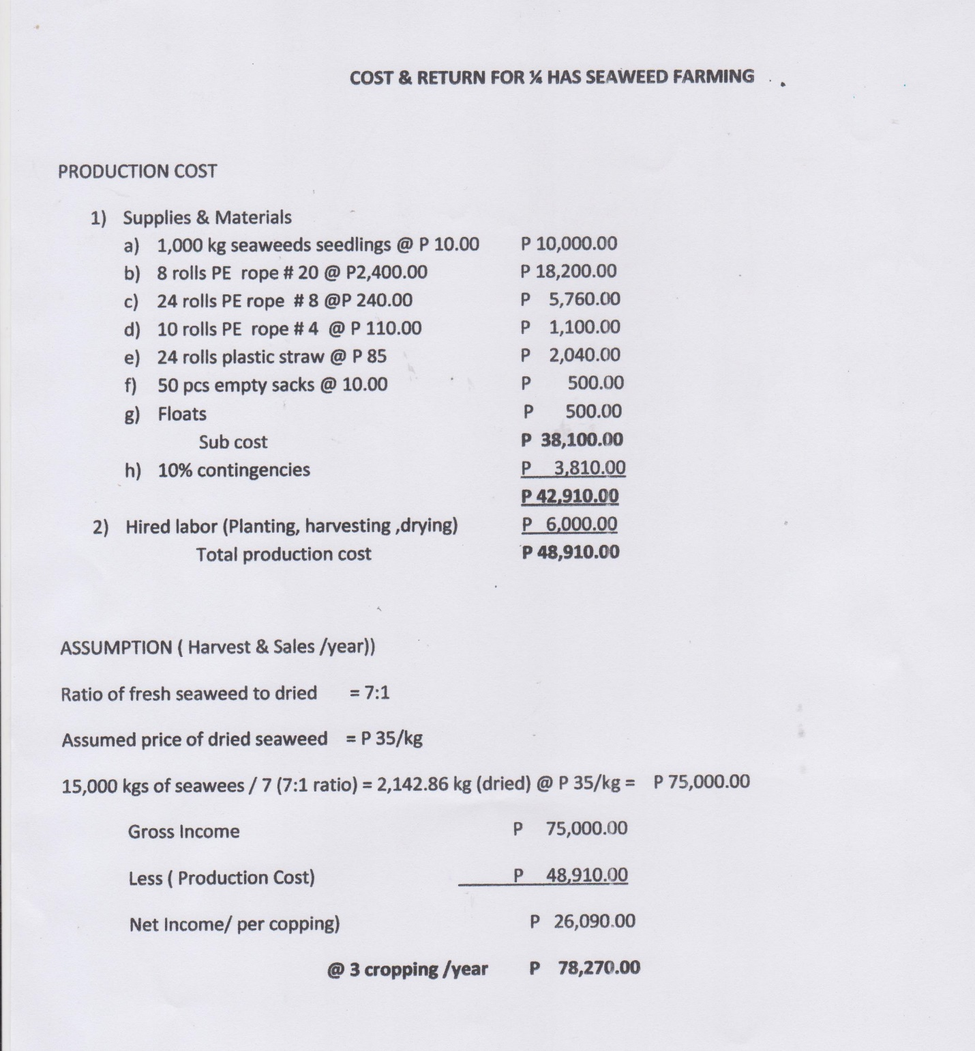
Source: Office of the Provincial Agriculturist

Table 12. Relative Financial Position of Seaweed Value Chain Players in CALABARZON, 2014
SEGMENT | INPUT PROVIDER | SEAWEED FARMER | TRADER | PROCESSOR/  EXPORTER
Seedlings |  | 10
Raw materials |  | 10 | 36 | 50
Labor |  | 3 | 1 | 6
Utilities |  | 5 | 1 | 3
Transportation |  | 1 | 3 | 8
Total Cost of production |  | 29 | 41 | 67
Profit |  | 7 | 9 | 23
Selling Price | 10 | 36 | 50 | 90
Profit Percentage |  | 18% | 23% | 59%

Relative Financial Position of Players
Relative Financial position of players is a tool used by analysts to determine the cost structure of each players of the value chain and its position when it comes to profit percentage sharing. For the case of seaweeds, the value chain players include input provider, seaweed farmer, trader and processor/exporter. Looking at the total cost of production and production of different players of the value chain, it can be concluded that processor/exporter generates the most profit compared with farmers and traders in the industry. Processor/exporter sell their processed seaweeds (carrageenan) at 90 pesos or 2 dollars but they only have a total cost of 67 pesos which is 59% in percent share of profit for the seaweed industry. The traders has a bit more profit than farmers with 9 pesos compared to 7 pesos of farmers with percent share of 23% and 18% respectively. All of the data that can be seen from table 12 were gathered during the key informant interview and focus group discussion conducted.

SECTION 4: MARKET AND MARKET OPPORTUNITIES
(Lifted from Palawan Seaweeds Value Chain Analysis)

- World Trade of RDS and RC/SRC

The world supply of RDS (for carrageenan production) is dominated by three countries: Chile, Indonesia, and Philippines. Over the past 10 years, the volume of world seaweeds exports increased by 42 percent, from 311,800 tons (US$427.2 M) in 2004 to 442,200 tons (US$784.4 M) in 2013. Highest level was attained in 2010 (550,000 tons valued at US$790 M) (Figure 11).

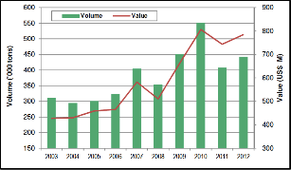

Source: UN Trade Map
Note: Volumes from 2007 to 2013were estimated based on the trends of previous years’ data.

Figure 11. World Exports of Seaweeds

- Raw Dried Seaweeds (RDS) Exports

By volume, Indonesia ranked as the number one exporter of seaweeds in 2013 (40% of total seaweeds exports, 176,100 tons valued at US$162.4 M). Other major exporters include: Chile (82,100 tons), Ireland (38,200 tons), Philippines (37,100 tons), Peru (28,000 tons), and South Korea (26,600 tons) (Figure 12).
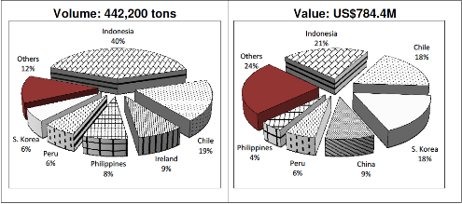

Note: Total volume was estimated based on the trends of previous years’ data
Source: UN Trade
Figure 12. Volume and Value of Raw Dried Seaweeds (RDS) Exports, 2013

- Carrageenan Exports
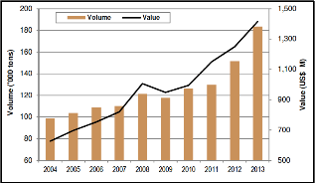
Source: UN Trade Map
*Carrageenan export data was lumped under classification code 130239 (Mucilage and
thickeners, modified or not, derived from vegetable products.

Figure 13. World Exports of Agar-Agar and Carrageenan, 2003-2012*
The volume of carrageenan exports (RC/SRC) surged by 86 percent over the past 10 years, from 98,700 tons in 2004 to 183,600 tons in 2013. Its value likewise more than doubled (from US$626.4 M in 2004 to more than US$1.4 B in 2013) during the same period (Figure 13).

China is a major player in global carrageenan trade. Among the major processors are Shanghai Brilliant, Green Fresh, and Shelly Food. These companies supply 66 percent of the Chinese world production of gel press carrageenan.

China accounts for 27 percent of the total volume of carrageenan exports in 2013, roughly 48,900 tons valued at US$425.7 M. Other major exporters include: Philippines with 23,500 tons (US$152.8 M), Germany with 11,900 tons (US$81 M), India with 7,800 tons (US$92.1 M), and Spain with 7,400 tons (US$62.6 M) (Figure 14).

In the global market, carrageenan is competing directly with product substitutes such as pectin, carboxy methyl cellulose (CMC), and microcrystalline cellulose (MCL). In the US market, there are 15 hydrocolloids products competing with carrageenan such as: agar, alginates, gum Arabic, CMC, gelatin, gellan gum, guar gum, locust bean gum, MC/HPMC, MCL, pectin, starch, tara gum and xanthan gum.

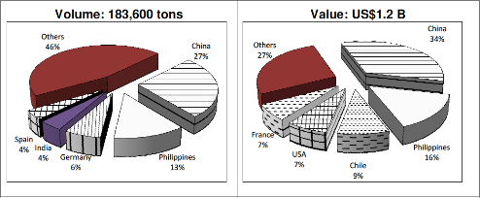

Source: UN Trade Map
Figure 14. World Exports of Carrageenan and Agar-Agar by Major Supplier, 2013

- RDS Imports

World imports of seaweeds increased by 71 percent from 341,300 tons (US$469.6M) in 2004 to 582,300 tons (US$1.1 billion) in 2013 (Figure 16). In 2012, China accounted for 47 percent (281,900 tons valued at US$425.7 M) of the global seaweeds imports. Other major importers include: Japan (46,500 tons), Chile (40,800 tons), Ireland (35,200 tons), and USA (30,100 tons).

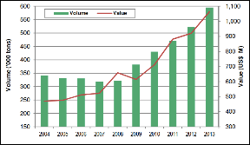

Note: Volumes from 2009, 2010, 2012, and 2013 were estimated based on the trends of previous
years’ data.
Source: UN Trade Map

Figure 15. World Imports of Seaweeds, 2003-2012

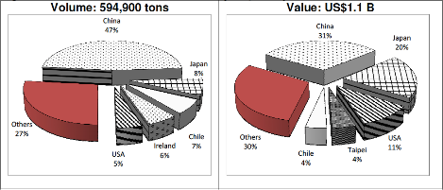

Note: Total volume was estimated based on the trends of previous years’ data.
Source: UNTrade Map

Figure 16. World Imports of Seaweeds by Major Buyer, 2013

- Carrageenan Imports

World imports of carrageenan and agar-agar rose by 38% from 126,600 tons in 2004 to 175,100 tons in 2013. For the same period, its value almost doubled from US$645.9 M in 2004 toUS$1.3 B in 2013 (Figure 16).

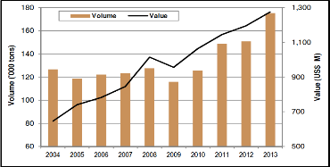

*Carrageenan import data was lumped under classification code 130239 (Mucilages and thickeners, modified or not, derived from vegetable products)
Note: Volumes from 2009, 2010, 2012 and 2013 were estimated based on the trends of previous years’ data.
Source: UN Trade Map

Figure 17. World Imports of Agar-Agar and Carrageenan, 2004-2013*

In 2013, the major importers of carrageenan included Germany (24,100 tons valued at US$12 M), US (11,600 tons valued at US$131.4 M), Belgium (7,600 tons valued at US$57 M), France (7,000 tons valued at US$45.8 M), and Spain (6,400 tons valued at US$53.4 M) (Figure 18).

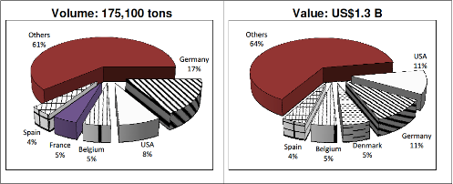
Source: UN Trade Map

Figure 18. World Imports of Carrageenan and Agar-Agar by Major Buyer, 2013

- Philippine RDS and RC/SRC Trade

Raw Dried Seaweeds Exports

From 2004 to 2013, Philippine annual exports of RDS declined by 4 percent in volume and increased by 15 percent in value. Annual average volume stood at 18,600 tons valued at US$30.7 M. In 2013, exports dropped by 36 percent from 21,000 tons (US$30.6 M) in 2012 to 13,500 tons (US$32.4 M). The biggest market for Philippine RDS is China, roughly 61 percent of the total volume in 2013 at 8,200 tons (US$3.3 M). Other markets were USA with 22 percent (3,000 tons); South Korea, 6 percent (800 tons); and, France and Spain, 3 percent each (400 tons each). In terms of value, Spain was the major buyer at US$13.2 M (Figure 20).

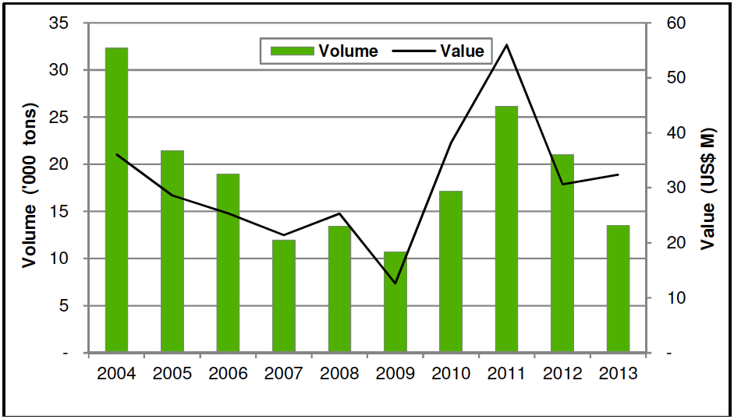

Figure 19. Philippine Seaweeds Exports (RDS), 2004-2013

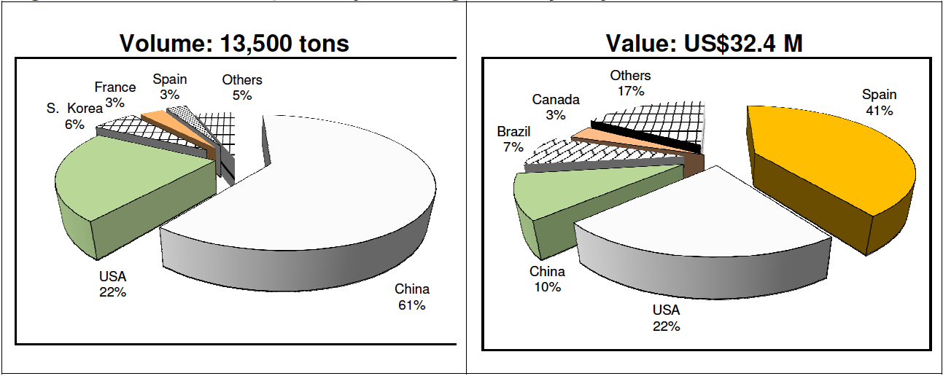
Source of basic data: BAS

Figure 20. Seaweeds Exports by Leading Country Buyers, 2013

Ninety-one percent (91%) of seaweeds exported in 2013 are in the form of Eucheuma chips (12,300 tons valued at US$6.3 M) while the rest (9%) are fresh, chilled, or dried (1,200 tons valued at US$26.1 M) (Figure 21).

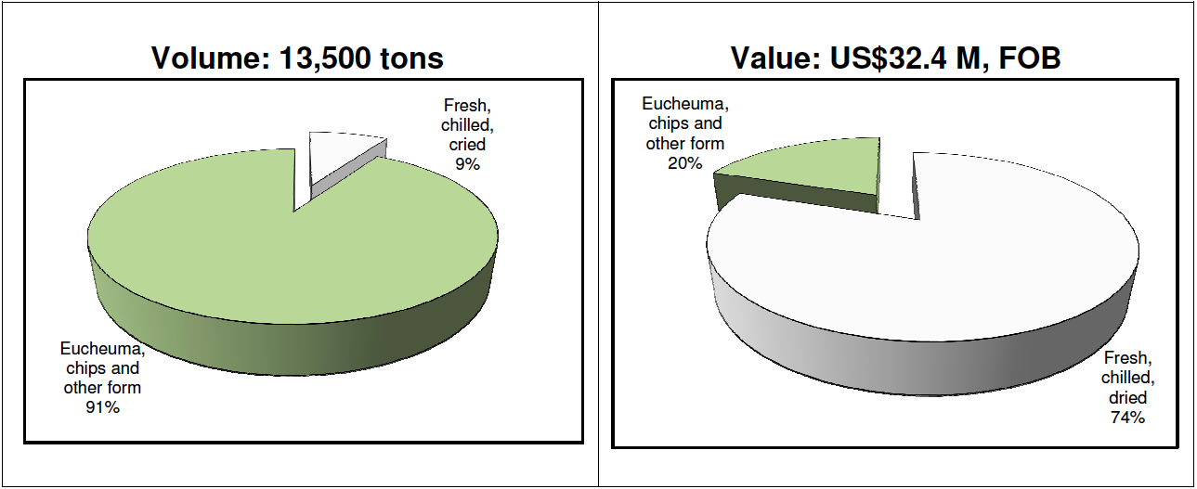
Source of basic data: BAS

Figure 21. Seaweeds Exports by Product Type, 2013

Carrageenan Exports (RC/SRC)

Over the past ten years, Philippine carrageenan exports fell by one percent in volume but increased by 18 percent in value. Average exports stood at 13,100 tons valued at US$101.5 M. In 2013, volume exported dropped by 34 percent from 12,900 tons (US$152.8 M) in 2012 to 8,600 tons (US$195.2 M). This could be attributed to the decline in seaweeds production in the country. The major markets of Philippine carrageenan exports include: USA (32%, 2,800 tons, US$49.8 M); UK (13%, 1,100 tons); Denmark (10%, 860 tons); Belgium (6%, 500 tons); and Thailand (4%, 300 tons) (Figure 22-23).
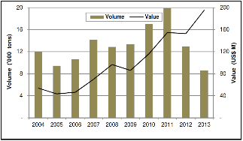

Figure 22. Philippine Carrageenan Exports, 2004-2013

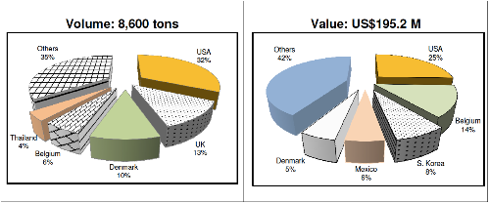
Source of basic data: BAS

Figure 23. Carrageenan Exports by Leading Country Buyers, 2013

RC accounted for 70 percent of Philippine carrageenan exports in 2013 (6,000 tons valued at US$133.7 M), followed by SRC at 27 percent (2,300 tons valued at US$37.3 M), and other carrageenan products at 3 percent (300 tons valued at US$24.2 M). The US RC market is composed of meat applications (45-55%), dairy (30-40%), and other applications such as air freshener gels, gravy, and sauces (Figure 24).

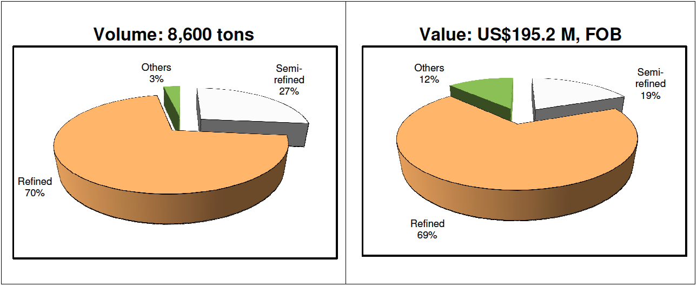

Source of basic data: BAS

Figure 24. Carrageenan Exports by Product Type, 2012

Indonesia has surpassed the Philippines in terms of RDS production as raw material for carrageenan, but the Philippines remains a major supplier of carrageenan to the United States. Philippine exports to the United States increased from 5,824 tons in 2011 to 6,308 tons in 2012.

It is interesting to note the dramatic shift of Philippine exports from RDS to RC/SRC. In 1998, 78 percent of Philippine seaweeds exports are in the form of RDS and only 22 percent are processed (RC/SRC). Ten years later, 87% of Philippine production are already in the form of RC/SRC and only 13 percent are in the form of RDS. The shift is mainly due to the price premium (differential) between RDS and RC/SRC which motivated Philippine processors to invest in higher value-adding activities (Figure 24).

- Raw Dried Seaweeds Imports

To augment the supply of RDS for carrageenan processing, the Philippines imports from Indonesia. FMC started importing from Indonesia in 2000 and Shemberg in 2004. In 2013, imports from Indonesia reached almost 20,000 tons. Over the past 10 years, seaweeds import volume and value (on the average) grew by 30 percent and 38 percent, respectively (Table 12).

In 2013, 87% of the Philippine seaweeds imports were sourced from Indonesia (6,400 tons valued at US$9.6 M). Other sources included: India, Chile, China, South Korea, and Fiji.

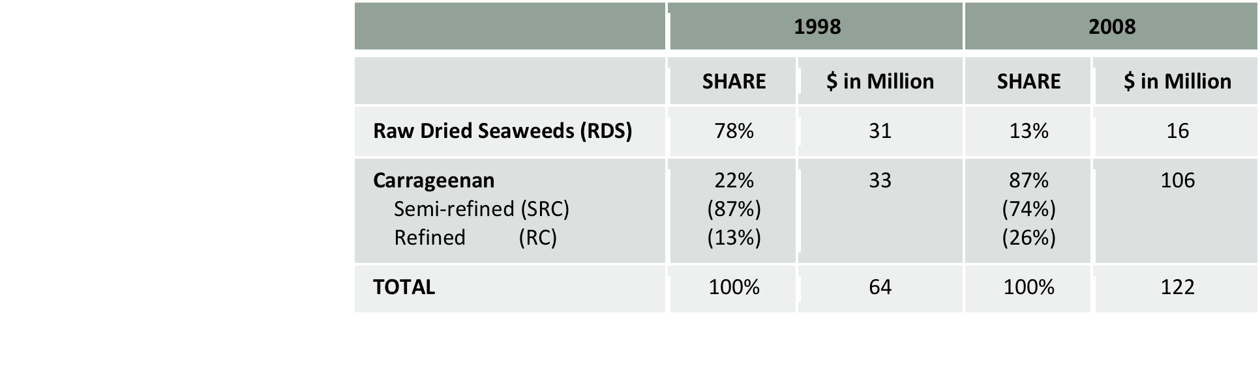
Source: Bureau of Export Trade Promotion
Table 13. Composition of Philippine RDS and RC/SRC Exports (1998 and 2008)

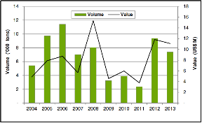

Source of basic data: BAS

Figure 25. Philippine Seaweeds Imports, 2004-2013

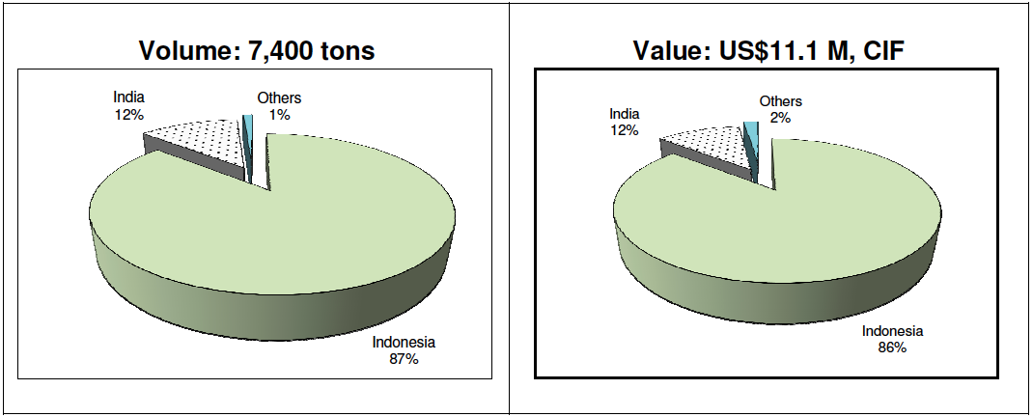

Source of basic data: BAS

Figure 26. Seaweeds Imports by Leading Country Suppliers, 2013

By product type, RDS imports in 2013 comprised of 53 percent fresh, chilled, and dried (4,200 tons valued at US$6.2 M) and 44 percent Eucheuma chips and other form (3,200 tons valued at US$4.9 M) (Figure 26).

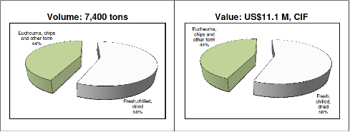

Source of basic data: NSO

Figure 27. Seaweeds Imports by Product Type, 2012

- Industry Structure

The industry is composed of five (5) multinational companies and nine (9) local processors. Among the multinationals are: CP Kelco, FMC Health and Nutrition, Kerry Food Ingredients Phils. Inc, Cargill Specialty Asia, and Ceamsa Asia Inc. Major local players are Shemberg Corporation, W. Hydrocolloids, Inc., Marcel Trading Corporation, TBK Manufacturing Corporation, and MCPI Corporation. Multinational companies import raw materials from Indonesia and other sources. Big local companies also import RDS from Indonesia but prefer locally sourced RDS.

Multinationals are relatively big and have operations in Europe, North America, Asia, and Latin America. Local companies, on the other hand, are usually family-owned corporations. They usually maintain regular (two to five) suppliers of raw materials.

Commercially, seaweed processing can produce two (2) very distinct products: (a) refined carrageenan (RC); and (b) semi-refined carrageenan (SRC).

In the Philippines, the traditional extraction process involves boiling the seaweed in alkali for long periods of time under oxygenated conditions. The carrageenan is bleached into solution, subjected to viscosity control so that the liquor can be pumped and filtered and then coagulated in alcohol or potassium chloride solution.

SRC is produced by dipping the dried seaweeds in alkali (at moderate temperature). Processing technologies for SRC is a blend of American and Japanese technologies utilizing the non-extractive method. The method leaves more than two (2) percent Acid Insoluble Matter (AIM) in the product, giving cloudier gels than refined carrageenan. The process flow of SRC Pet Food and SRC Food Grade are presented in Annexes B and C.

RC processing technologies in the country have been adopted from Danish, Japanese, French, and Taiwanese technologies and utilize the extractive method. This method allows the extraction of pure carrageenan after alcohol precipitation. The process flow of refined carrageenan is presented in Annex D.

The Philippines is the second largest SRC food grade manufacturer in the world next to China. It has lost the SRC pet food market to Indonesia. For refined carrageenan, the Philippines ranks third, after the United States (FMC Corporation) and Denmark (Hercules, Inc.).

Currently, there are fourteen (14) carrageenan processors in the country. In terms of RC process, only Shemberg Biotech Corporation produces the alcohol precipitated carrageenan (APC) while gel press carrageenan (GPC) is produced by CP Kelco, Cargill (Phil. Bio-Industries), and W. Hydrocolloids. The rest are producing SRC (Table 14).

Table 14. Philippine Carrageenan Processors (2014)
Carrageenan Processor | Products
Multinationals
P Kelco | RC –GPC
Ferry Food Ingredients Phils, Inc. | SRC
MC Health and Nutrition | SRC
Cargill Specialty Asia (Phil Bio-Industries) | SRC
Ceamsa Asia, Inc. | SRC
Local Companies
Hydrocolloids, Inc. | RC-GPC
Chemberg Biotech Corporation | RC-APC
Chemberg Marketing Corporation | RC-GPCSRC
Marcel Trading Corporation | SRC
BK Manufacturing Corporation | SRC
Zamboanga Carrageenan Manufacturing | SRC
Accel Carrageenan | SRC
Mega Polysacharide | SRC
Mioka Biosystems Corporation | SRC
Note: APC –alcohol precipitated carrageenan; GPC – gel press carrageenan;
SRC – semi-refined carrageenan

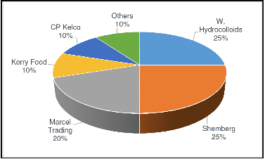

Source: Seaweeds Industry Association of the Philippines (SIAP)

Figure 28. Estimated Market Share of Carrageenan Processors, 2014
The biggest players in the industry are W. Hydrocolloids (25%), Shemberg Corporation (25%), Marcel Trading Corp. (20%), Kerry Food Ingredients (10%), CP Kelco (10%), and the rest are shared by FMC, MCPI and other players (Figure 28).

Table 15. Company Profile of Major Carrageenan Processors in the Philippines
Processors | Company  Profile
W Hydrocolloids, Inc. | W Hydrocolloids has more than 30 years of experience in the carrageenan industry. The company manufactures carrageenan products through its regional production facilities in Carmona, Cavite, Philippines. Its products are marketed under the trade name RICO® CARRAGEENAN  Source: (www.rico.com.ph, July 3, 2014)  RICO is available in food and non-food grade semi-refined kappa and iota carrageenan. The company has partners, affiliates, and subsidiaries for the production of refined kappa carrageenan and other carrageenan fractions (iota, lambda, kappa 2). It also operates regional stations for sourcing and supply of Eucheuma cottonii and Eucheuma spinosum seaweeds. Rico's team of experienced and competent carrageenan specialists continuously develop and create ways of expanding the uses of carrageenan in various applications truly living up to its aim of exploring "A World of Possibilities".
Shemberg Corporation | Shemberg started as a seaweed exporter in 1966. As the demands of the market grew rapidly, Shemberg transcended into a one stop shop of all kinds of carrageenan – Kappa, Iota and Lambda – rendering different application from dairy, meat, confectionery, pharmaceutical, cosmetics, water jellies, desserts, beer and pet food. For over four decades, Shemberg developed its products with conformance to the Philippine and International Standards that ensures safe and high quality.  Spanning almost four decades of pioneering experience in carrageenan production and processing, Shemberg has maintained its highest standards in producing carrageenan for various food, pharmaceutical, personal care, oral care and other nonfood applications. Shemberg is an active participant in discovering and furthering technologies in the production and application of carrageenan in response to the ever evolving needs of the world market. It prides itself as a world-class producer of carrageenan with the innovative spirit that has allowed it to further the interest of consumers worldwide by providing processors and manufacturers with novel technologies, benefits, cost-effective and functional carrageenan polymers. Its products are being marketed under the following names: BENGEL, BENVISCO, BENLACTA, PUREGELL, and BENSTABI. Shemberg has evolved and developed multitudinous applications of carrageenan with three facilities catering to world class standards.  (www.shemberggroupofcompanies.com, July 3, 2014)
Marcel Trading Corporation | Marcel Trading Corporation started business in 1969, exporting various sea products. In 1971, Marcel added dried seaweeds to its range of exports. Because of its policy of strict quality control and good value, the company quickly established strong supply relationships with many Carrageenan processors worldwide. As one of the major suppliers of dried seaweed to the Carrageenan Industry, Marcel had been extensively involved in seaweed farming activities, which in turn has helped provide livelihood for hundreds of farmers and spur economic growth in seaweed farming areas in the Philippines.  From supplying dried seaweed raw materials, Marcel diversified into carrageenan processing in 1977, using Kappaphycus alvarezii (Eucheuma cottonii) and Eucheuma Denticulatum (Eucheuma spinosum) as the main raw materials for producing Kappa and Iota Carrageenan.  Through years of experience, Marcel has developed an expertise in raw material procurement, carrageenan processing, food ingredients formulation, quality control and assurance, product development, financing, marketing, and technical assistance to customers. Now, Marcel owns and operates two carrageenan production plants and one blending facility. The company also has marketing affiliates for local and worldwide sales and maintains warehouses to carry stocks of popular products in the US, Europe, and Asia. (www.marcelcarrageenan.com, July 3, 2014)
CP Kelco | CP Kelco is a multinational carrageenan company in the Philippines. In 1997, CP Kelco established its carrageenan plants in Cebu as the innovation leader in the production of polysaccharides by microbial fermentation, extraction from land and sea plants, and modification of cellulose-based raw materials.  CP Kelco’s history spans over 125 years, dating back to when the J.M. Huber Corporation was founded in 1883. The company’s products are derived from natural, renewable raw materials, and CP Kelco strives to provide these products with minimal modification. These products serve many functions, including viscosity modification, thickening, suspension, stabilization and gelation (www.cpkelco.com, July 3, 2014).  CP Kelco has more than 40 years of experience in carrageenan production. CP Kelco is working with a brand portfolio of carrageenan products and is well prepared to serve customers as an acknowledged and reliable partner. CP Kelco can help customers master the art of creating texture or stabilization of consumer products. Commercial carrageenan products are frequently standardized for obtaining optimal gelling and thickening properties. By using the appropriate carrageenan product, the formulator can create textures ranging from free-flowing liquids to solid gels. In addition to offering standard types, CP Kelco works in conjunction with customers to develop new products and formulations for specific applications. Carrageenan from CP Kelco is marketed under the following names:  GENULACTA® types are standardized for milk applications  GENUGEL® types are standardized for water and meat applications and are used in personal care and household products  GENUTINE® types are gelatine alternatives  GENUVISCO® types are used as thickening, stabilizing, gelling and texturizing agents  GENU® PLUS types are standardized for use in marinated meat and poultry  GENU® Texturizer types are blends of carrageenan and other hydrocolloids
Kerry Food Ingredients (Philippines), Inc. | Kerry started its operations in 1972. Its history traces the evolution and growth of Kerry Group – from its modest beginnings in the south west of Ireland into a leading player in the global food industry. Commencing from a green field site in Listowel, Co. Kerry, Ireland over 40 years ago, Kerry Group has realised sustained profitable growth with current annual sales of approximately €5.8billion. The dynamics of all food and beverage markets, lifestyle changes and the internationalization of food tastes with a growing preference for convenience, variety and quality prepared foods or snack products, means the Group's worldwide businesses are well positioned for continued growth and development.
FMC Health and Nutrition | FMC Health and Nutrition is the largest and most experienced producer of carrageenan, alginates and Avicel® MCC worldwide. During the past 60 years, FMC BioPolymer has established a tradition for providing high quality ingredients to the Food Ingredients industry.  The company develops and customizes blends of carrageenan for specific gelling, thickening, and stabilizing properties. FMC is one of the largest and most experienced producer of carrageenan extracts worldwide. During the past 60years, FMC Health and Nutrition has established a tradition for providing high quality carrageenan, technical expertise, and service. FMC BioPolymer builds quality and performance into its carrageenan products at three levels—seaweed sourcing, extract manufacturing, and understanding and tailoring the functional properties of each product.  As a global leader utilizing advanced technologies and customer-focused research and development, FMC provides innovative and cost-effective solutions to food and agriculture, pharmaceutical, healthcare, pulp and paper, textiles, glass and ceramics, rubber and plastics, lubricants, structural pest control, turf & ornamental markets, specialty and related industries (www.fmc.com, July 3, 2014)
MCPI Corporation | MCPI Corporation launched operations in 1983, initially leasing a seaweeds processing facility of Marine Colloids (Philippines), Inc., a wholly owned-subsidiary of a multi-national company based in Chicago, Illinois. When the subsidiary ceased its operations in the Philippines due to turmoil in the country’s political and economic environment triggered by the 1984 People Power Revolution, MCPI was awarded its first large exclusive five-year supply agreement contract for FMC Corporation and its major customers. This opportunity provided the resources for MCPI to construct its own plant in Cebu.  The MCPI Corporation manufactures natural grade carrageenan that can be used for various food and non-food applications. The company is involved in seaweed cultivation in Danajon Bank and also supplies seaweed raw materials to carrageenan processors. Aside from their own farm, the company sources from small farmers all over the Philippines and operates a plant in Cebu which produces carrageenan at an annual rate of 1,500 tons with provisions for expansion to 3,000 tons annually.
TBK Manufacturing Corporation | TBK Manufacturing Corporation was established in 1999. The company has been engaged in the export of marine products for more than 20 years now and retains a firm foothold in the global market. TBK aims to earn recognition as one of the best international suppliers of high quality, cost-effective carrageenan to customers worldwide.  Situated near the heart of one of the largest seaweed producing areas of the Philippines, TBK has cultivated supply agreements with reputable seaweed producing cooperatives and organizations to ensure the supply and availability of first-rate raw materials.  With more than 30 years of cumulative industry experience, the invaluable experience and modern facilities of the TBK R&D Team are also made available to customers who require assistance in formulating new applications and products. (http://jorgeduquillo.fm.alibaba.com/company_profile.html, July 3, 2014)
Cargill Specialty Asia | Cargill Specialty Asia is one of the world’s leading suppliers of texturizers and emulsifiers to the global food and beverage industry, as well as the pharmaceutical and cosmetics markets. Cargill Specialty Asia is a global business with activities in 24 countries over all major regions. The company offers specific solutions for providing texture in multiple food applications, based on a wide palette of ingredients, including hydrocolloids, lecithins, starches, soy flour, functional systems and emulsifiers.  Cargill has two carrageenan (hydrocolloid) production plants in the Philippines. Located in Canlubang, Laguna, this joint-venture plant, Philippine Bio-Industries (PBI), is fully automated, produces gelling carrageenan from locally sourced seaweed and is ISO 9001:2000 certified.  Cargill started doing business in the Philippines in 1947 when the vegetable oil division started buying copra for export to the United States. It was Cargill’s first office in Asia. Cargill Philippines now employs over 460 people throughout the archipelago. The primary offices are in Makati City (headquarters), Bulacan, Laguna, and General Santos City, with several satellite offices in strategic locations all over the Philippines. Operations include grain and oilseed originating and processing, commercial feeds manufacturing, texturizing and sweeteners solutions for food and beverage applications. (www.cargill.ph, July 3, 2014)
CEAMSA Asia Inc. | CEAMSA Asia Inc. is a semi-refined carrageenan manufacturing plant that utilizes technology developed by its parent company in Spain. They are involved in manufacturing and supplies a comprehensive range of high quality carrageenan and pectin products to the global food industry. In February 2009, CEAMSA Asia Inc. was incorporated and registered in the Philippines to be the first international venture of CEAMSA. The company is 99.99% owned by CEAMSA Spain. They’re products are 100% percent exported. In addition, as an export oriented firm, CEAMSA ASIA INC. is a bonafide Board of Investment registered enterprise. (http://camaraespanola.files.wordpress.com,July 3, 2014)
Zamboanga Carrageenan Manufacturing Corp. | Zamboanga Carrageenan Manufacturing Corporation together with its sister company, LM Zamboanga United Trading, is one of the key players in the Seaweed business in the southern part of the Philippines, specifically Zamboanga City. It has set a very high standard in the acquisition of raw seaweed as well as in the processing of semi-refined carrageenan. Zamboanga Carrageenan is an exporter of semi-refined carrageenan and among the top exporters of RDS. The company also exports sun-dried white seaweed which is used in Asian Cuisine, when rehydrated it takes the form and texture of newly harvested seaweed. (http://jorgeduquillo.fm.alibaba.com/companyprofile.html, July 3, 2014)
Accel Carrageenan Corporation | Accel Carrageenan Corporation (ACC) is a new name in food grade semi-refined carrageenan. Formerly RICO PHILIPPINES Industrial Corporation (RPIC), the new company was further enhanced and expanded to suit the growing demand of quality carrageenan products.  Established in 1990 through a joint venture of Rico Industrial Taiwan and Marcel Trading Corporation (MTC) of the Philippines, RPIC’s initial activities were focused on producing both semi-refined and refined carrageenan under an exclusive selling arrangement to MTC.  In early 2000, RPIC, still the sole supplier of MTC, moved up to producing food-grade semi-refined carrageenan. Seventy percent (70%) of its output was channeled by Marcel to carrageenan buyers in Asia, Europe, and the United States. The remaining 30% was sold to the domestic market through an affiliated distribution company serving the top food corporations and conglomerates in the Philippine market. (http://www.accelcarrageenan.com/index.htm)
Mioka Biosystems Corporation | Mioka Biosystems Corporation (MIOKA) is a manufacturer and supplier of food grade carrageenan. It has its own farming site in Zamboanga, where there is abundant supply of seaweed raw materials. Its manufacturing plant is located in Canlubang Laguna. Carrageenan products from Mioka can be customized based on each customer’s specific needs. Mioka works with its customers to develop the best possible functional Carrageenan system for their products. It manufactures semi refined food grade carrageenan.

Carrageenan processors are mostly located in Cebu and Luzon. There are currently six carrageenan processing plants in Cebu, two in Zamboanga, two In Laguna, two in Cavite, one in Bulacan, and one in Leyte (Table 15).

Seaweeds from Palawan are usually shipped to Cebu and Manila/Cavite via Mindoro-Batangas. A small volume goes Puerto Princesa then to Manila. Bulk of seaweeds from Agutaya are delivered straight to Manila/Cavite/Laguna via Mindoro.

Table 16. Spatial Concentration of Carrageenan Processors
Carrageenan  Processor | Plant  Location
Multinationals
P Kelco | Sibonga, Cebu
Ferry Food Ingredients Phils, Inc. | Lapu-lapu City, Cebu
MC Health and Nutrition | Mandaue City, Cebu
Cargill Specialty Asia (Phil Bio-Industries) | Canlubang, Laguna
Ceamsa Asia, Inc. | Marilao, Bulacan
Local Companies
Hydrocolloids, Inc. | Carmona, Cavite
Chemberg Biotech Corporation | Carmen, Cebu
Chemberg Marketing Corporation | Mandaue City, Cebu
Marcel Trading Corporation | Zamboanga City
BK Manufacturing Corporation | Tacloban City, Leyte
Zamboanga Carrageenan Manufacturing Corp. | Kasanyangan, Zamboanga City
Accel Carrageenan | Carmona, Cavite
Mega Polysacharide | Maasin, Zamboanga City
Mioka Biosystems Corporation | Canlubang, Laguna
Source: SIAP

There are important criteria being considered in choosing a processing plant location: access to raw material source; abundant water supply; reliable power supply; availability of manpower; wi1th port facilities and good shipping frequency; availability of support industries; and good peace and order situation.

Most carrageenan processors are now into final blending. In fact, most carrageenan exports are now blended products (unlike the pure carrageenan exported in the 1990s). Final blending is done to conform to the demand (requirements, specifications) of users (end buyers). Usually, carrageenan products are blended with salt or other hydrocolloids as specified by the buyers.

- Benchmarking Seaweed Competitiveness

Overall, Philippines RDS ranked higher than Indonesian RDS with the exception of price and moisture content. The properties, consistency, percentage of acceptable foreign matter, and gel strength and color were considered to be relatively better in the Philippines. The ranking of quantity and reliability of suppliers were fairly close. In terms of quantity, processors considered the current total national cottonii production and scored the Philippines higher but this may definitely change as Indonesian production increases.

The relatively higher scores of Philippines RDS did not come as a surprise to traders and exporters but some questioned why processors were shifting to Indonesia if basic qualities were perceived to be inferior to the Philippines. It was recognized that for processors, price and gel strength are ultimate the key CSFs for RDS competitiveness (Figure 28).

These results are only a snapshot of current opinions and comparative advantages today may be slowly eroding as the Indonesian seaweed industry becomes increasingly more competitive. RDS is a global commodity that is primarily price-driven but product differentiation based on a few of these CSFs (availability, consistently superior properties, etc.) could be promoted to maintain a competitive edge over rival suppliers.

Figure 29. Benchmarking Philippines RDS

- Market Potential

The market is huge and growing, especially for dairy and meat. The biggest markets are still the Americas, Europe and Japan. The Philippines remains a strong supplier of carrageenan in the US market. According to industry players however, it is expected that the Chinese carrageenan processors will increase its market share and keep a lid on prices. Chinese buyers of raw materials are notorious for outbidding most other buyers in search for raw material.

Carrageenan suppliers are making strong efforts to produce customized and differentiated products to move away from the “commodity status.” A higher level of specialization is being done for nutraceutical use. Obtaining approval is likely to be more difficult than in standard food application, but the barriers to competitive entry will be more difficult to surmount. This is a specialty and niche (small) market which processors are able to target. Hydrocolloid consumption in the various food applications amounted to two (2) million tons worth US$7 billion in 2013. For carrageenan, meat application is the most important, at 45-55 percent share of the food market.

Table 17. Hydrocolloid Markets – All Applications, 2013
Applications | ‘000 Tons | US$/Kg | US$ Million
Industrial | 5,460 | 1.89 | 10,290
Food | 2,080 | 3.42 | 7,120
Oilfield | 3,020 | 2.11 | 6,370
Total | 10,560 |  | 23,790
Source: Industry Players

Table 18. Food Hydrocolloid Market, 2013
Hydrocolloid | ‘000 Tons | US$ Million
Gelatin | 201.3 | 1,758.1
Starches | 1,499.7 | 1,616.7
Pectin | 54.0 | 856.0
Carrageenan | 50.4 | 615.9
Xanthan | 72.1 | 606.1
Agar | 11.9 | 321.1
Alginates | 15.0 | 306.2
CMC | 42.0 | 225.6
Guar | 48.3 | 223.0
Arabic | 49.6 | 199.7
MCC | 12.5 | 119.3
LBG | 11.0 | 106.6
MC/HPMC | 8.3 | 100.3
Others | 6.5 | 68.4
Total | 2,083 | 7,123
Source: Industry Players

Table 19. World Demand on Eucheuma Species, 2001-2003
Seaweed Species | 2001 | 2002 | 2003
Eucheuma cottonii | 169,000 MT | 180,000 MT | 220,000 MT
Eucheuma spinosum | 15,000 MT | 18, 000 MT | 22,000 MT
Note: Projected annual increase in demand: E. cottonii – 10%, E. spinosum – 7%.
Source: Seaweed Industry Association of the Philippines (SIAP)

Source of basic data: SIAP

Figure 30. Projected World Demand on Eucheuma Species, 2003-2023
Figure 30 shows a huge demand to meet by the seaweed industry in the years to come. Estimated demand for Eucheuma cottonii and Eucheuma spinosum in 2023 are 660, 000 MT and 52, 800 MT, respectively. Such estimation was made accordingly after the projection by the Seaweeds Industry Association of the Philippines that Eucheuma cottonii’s demand will increase up to 10% annually while Eucheuma spinosum will potentially increase by 7% every year from the base year 2003. This projection opens a wide range of opportunity to our seaweed stakeholders especially to our farmers.

- Product Distribution

Dried seaweed are produced in tremendous quantities by 1,684 seaweeds farmers in Palawan. The marketing channel consists of farmer-producer, small traders or middlemen, large traders or agents and exporters/processors.

Basically, dried seaweeds are exported locally in Cebu and Manila for further processing. There are collection centers where seaweeds from various production areas are collected and sent to local exporting centers. In some areas of the Province, there were presence of viajeros and collectors or buying agents. They normally went to the production areas or seaweeds farms to buy dried seaweeds and trade it to the local traders. There were seaweeds producers in the province who directly trade their products to the processors based in Cebu or Manila (Figure 31).

Seaweeds from Agutaya, Roxas and Taytay are usually shipped to Cebu and Manila/Cavite via Mindoro-Batangas. A small volume goes Puerto Princesa then to Manila. Bulk of seaweeds from Agutaya are delivered straight to Manila/Cavite/Laguna via Mindoro.

Collectors/
Buying Agents
Viajeros
Local
Traders
Cebu/Manila
Based Seaweed Processor
Seaweeds
Farmers

Source: Industry Players

Figure 31. Prices of RDS and RC/SRC

- RDS Prices

The Philippines and Indonesia are both trading Eucheuma seaweeds in the international market. In 2013, Philippine RDS fetched a price of US$1,100-1,200/ton (or $1.0-1.20/kg.), a little higher than Indonesian RDS by US$100-200/ton. This year, Philippine RDS price increased to about US$1,800-2,000/ton, still performing better than Indonesian RDS at US$1,700/ton (computed at 38% moisture content). Comparatively, prices of seaweeds from the Philippines are about 12 percent higher than those from Indonesia, mainly due to better quality of Philippine seaweeds (Figure 32).

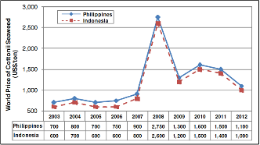

Figure 32. RDS Price: Philippines vs. Indonesia, 2003-2012

Box 2. RDS Price Spike in 2008

The “cottonii crisis” of 2008 was a result of prices rising sharply to unprecedented levels. Several factors contributed to the 2008 cottonii crisis but the root cause was the shortfall in supply (lower level of production). The “unusual” aggressive buying by some processors set off a period of panic buying and prices skyrocketed to US$2,750 per ton.

- Carrageenan (RC/SRC) Prices

Carrageenan prices have averaged at US$14/kg for SRC and US$10-11/kg for RC for the period 2010-2013.In 2013, the average carrageenan prices in the US were pegged at US$14.19/kg (for refined carrageenan) and US$10.89/kg (for semi-refined carrageenan) (Figure 32).

- Local Prices

The average price of seaweeds from 2004-2015 is growing at 9.6 percent. In 2014, the average price of dried seaweeds in Palawan is 67 pesos per kilo, 6 percent higher from 2013 production. The price of seaweeds varies depending on which time of the year. In 2014, the price of seaweeds according to class is as follows: (1) Class A costs 67 pesos per kilogram and (2) Class B costs 30 pesos per kilogram. The price of seaweed starts to go up from August to December. During these months, the volume of production is low due to strong winds brought about by the northeast monsoon (hanging amihan). While the price starts to go down come January to June due to increase in the volume of harvest attributed to hanging habagat. The fresh weight farm gate price of dried seaweed in the first quarter of 2015 is PHP55.00 per kilo in Palawan (Table 14.

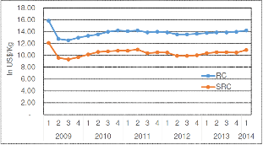
Figure 33. US Prices of RC and SRC, 2009-2014

Table 20. Dried Seaweed: Prices (In pesos per kilogram)
Year | Farm Gate Price
2004 | 39
2005 | 19
2006 | 39
2007 | 42
2008 | 65
2009 | 65
2010 | 51
2011 | 58
2012 | 60
2013 | 62
2014 | 67
2015 | 55
Source: Industry Players

Section 5. SUPPORT SERVICES
(Lifted from Palawan Seaweeds Value Chain Analysis)

The countryʻs seaweed industry has a brighter production outlook as the sector implements new strategies and tap new markets, the Seaweed Industry Association of the Philippines (SIAP) (President Jimbo Pedrosa said on August 7, 2015) during the FGD conducted at El Cielito Hotel, Makati. By 2016, (Cacho, K. O. June 12, 2013) wrote that “the seaweed industry cluster is expected to record domestic and export sales of $14 million to $394 million, respectively by tapping new markets in Asia, South America and Africa for quality seaweed-based products like raw dried seaweed, carrageenan and agar.” The Bureau of Fisheries and Aquatic Resources (BFAR) technical director Evelyn Martinez expressed her support for the seaweed industry’s future plans not only in Tawi-tawi, stressing the need for seaweed farmers and growers to produce more “superior, high quality seaweeds’ that can command higher prices for the commodity, but also in the whole country. According to (Lucero, R. C., 2015) Seaweed Action Officer of BFAR CALABARZON, there is a need for key people to be well-organized, key players in the industry to be trained in proper seaweed growing procedures, and also ample supply with “guaranteed quality seaweed seedlings” to make these all possible.
The Bureau of Fisheries and Aquatic Resources (BFAR) have made a significant contribution towards increasing seaweeds productivity. Infrastructure and post-harvest facilities were provided to accelerate the socio-economic condition of the fisher folk in the province of Quezon and Batangas with a number of growing families in the region. This development assistance is designed to develop and manage the fishery folk. The Bureauʻs development efforts are focused on the expansion and revitalization of productivity programs and provision of support activities through appropriate technology, research, extension and adequate financial and marketing assistance. An effort on conservation, protection, and sustained management of the fishery and aquatic resources to ensure it long term sustainability was also undertaken in prime Marine Protected Areas MPAs in the region.
While in Palawan, the Bureau’s intervention is exactly the same effort of enhancing the industry’s productivity and profitability, that of which resembles and exactly the same in region IV-A and these are as follows:
- Seaweed Development Project - This project aims to increase seaweed production and at the same time enhance the R & D projects and activities to further address the concerns and issues besetting the seaweed industry. The major projects being undertaken include inventory of seaweed resources, resource assessment, seaweed farming, product technology development;

- Organization/Strengthening of Fisheries and Aquatic Resources Management Councils (FARMCs) - The Bureau support the establishment and/or strengthening of FARMCs at the municipal levels to ensure the proper management and control over fisheries and aquatic resources through active and extensive participation of various stakeholders in the industry;

- Monitoring, Control and Surveillance (MCS) - This project aims to make effect the declared policy of the State to keep and ensure the integrity of marine fishery resources of the country in its optimum productive condition. MCS forms the backbone of the implementation of any ocean-related policy and serves as a tool/mechanism for the implementation of the fisheries management plan (FMP). It has 3 components: a) monitoring - data collection and analysis; b) control-legislation and administrative ordinances; and c) surveillance - law enforcement;

- Fisheries Law Enforcement - In order to effectively implement various fisheries laws and regulations, BFAR encourage fisherfolk communities to police and manage their own fisheries resources. The enforcement of laws includes, specifically the ban on the use of explosives, noxious substances and fine-meshed nets, the ban on commercial fishing within municipal waters and all other measures that will be instituted for particular fishing areas in coordination with the non-government organizations and the LGUs in the locality. Included in this project is the deputation of members of fisherfolk organizations/cooperatives and other qualified fisherfolks as fish wardens;

- Promotion of Value-Added Fishery Products – The project aims to reduce post-harvest losses and to promote/develop/formulate new value-added products by utilizing non-traditional fish species.
- Municipal Fish Ports – This caters to the post-harvest requirements of the sustenance fishermen, providing smaller fish landing and market facilities in selected fishing villages in the Province. These ports also serve as satellite ports for the large municipal fish ports and are mostly managed by the Local Government Units (LGUs);

- Market Assistance Project – This project considers the urgent need for a responsive marketing system from production areas to consumers. Included in this project are the continuous institutional support to build the capabilities of fisherfolk’s organizations to undertake marketing functions and provision of support services such as market information and market matching between buyers and sellers of fish and fishery products;

- Fisheries Extension Service – BFAR in collaboration with LGUs will expand and strengthen existing extension services at the local level. It envisions transfer of new technologies in fisheries to its clientele, particularly the fisherfolk, to increase their fish catch and income;

- Operation of the BFAR Research Outreach Stations (ROS) – The ROS stations serve as experimental farms for fisheries which will be engaged in technology verification and adaptation to produce quality breeders and fish stocks and conduct demo trials for fisherfolk/fish farmers; and

- Fisheries Research & Development Projects - In recognition of the important role of fisheries research in the development, management, conservation and protection of the provincial fishery and aquatic resources, BFAR conduct research and development to include technology generation, verification, and adaptation on aquaculture development, marine fisheries development and management and post-harvest technology to include product standardization and development of code of practices for fish and fishery products.

To further advance the competitiveness of the industry, there were key institutions both public and private that help and promote the productivity enhancement of the industry through research and development, policy formulation, marketing and other support services as follows:

Table 21. Summary of Key Institutions and Programs and Services
Key Institutions | Programs and Services
Organized Seaweeds Associations | The seaweeds farmers organized themselves into association to access support from BFAR and the LGU. The role of the association is to organize members if there are trainings to be conducted. The association is also important in the management of the distribution of supports provided by BFAR to seaweed farmers i.e. seedling dispersals and farm implements (PE ropes, soft tie, and floaters) to target member-beneficiaries.
Local Government Units | The LGU manages its municipal waters. It has the power to formulate ordinances, resolution, policies and programs consistent with the framework of local autonomy. The LGU also help in organizing seaweed farmers and in conduct seaweed training among farmers
Land Bank of the Philippines | Under the BFAR-LBP Partnership agreement, seed money is required to finance the purchase of the initial stock to be used for the nursery stock. BFAR program includes establishing a model farm which can serve as a training and demonstration farm and where the harvests shall be used as seedling for multiplier nurseries, as well as drying facilities and trading posts with warehouse
World Wildlife Fund Philippines | Establish an LGU-based marine mammal rescue network, which has been monitoring stranding and spearheading rescues of dugongs inadvertently caught by fishing gears in the area. Green Island Bay has extensive seagrass beds which are important habitat for the endangered dugong or sea cow. The bay is the last few remaining habitats in the world for the species that is fast declining in numbers.  WWF-Philippines continue to work with the Roxas municipality in providing institutional support for dugong conservation (wwf.panda.org).
Department of Trade and Industry | Establish shared service facilities i.e. drying platforms
Department of Environment and Natural Resources | Issues permits, clearances under the Clean Water Act and Environment Impact Assessment
Seaweeds Industry Association of the Philippines | Played a major role in the continual development and improvement of the seaweeds industry of the Philippines.  Support over 200,000 seaweeds farmers, 500 local and regional traders, 15 carrageenan processors and more than 10 seaweeds exporters
SECTION 6. ENABLING ENVIRONMENT
(Lifted from Palawan Seaweeds Value Chain Analysis)

This section discusses the ordinances and governing laws including its mandates and objectives. Thus, it underscores the ENABLING ENVIRONMENT needed for the furtherance of the growing industry of seaweeds.

Table 22. Summary of Relevant Laws/ Ordinances and the Mandates/Objectives
RELEVANT LAWS / ORDINANCES | MANDATE / OBJECTIVES
Republic Act No. 8435, otherwise known as the Agriculture and Fisheries Modernization Act (AFMA) of 1997 | Outline strategic measures on modernizing the fishery sectors of the country in order to enhance their profitability, and prepare the sectors for the challenges of globalization through adequate, focus and rational delivery of support services, appropriating funds thereof, and for other purpose.
Propose House Bill No. 2778 during the 1st ARMM Seaweed Congress last September 12, 2011. | This bill is about the proposed creation of Seaweeds Development Authority. This is being spearheaded by Hon. Tupay Loong for the purpose of promoting rapid, integrated development and growth of the seaweed industry in all its aspects and to ensure that the seaweed farmers become direct participants in, and beneficiaries of such development and growth.
Fishery Code (RA 8550) | Primary legislation for fisheries management in the country that grant powers to the LGU to grant license and fishing privileges to registered fishers and seaweed farmers as well as to register motorized boats with tonnage of three tons and below.
Fisheries and Aquatic Resource Management Council (FARMC) | Recommended policies and programs affecting their municipal waters. Most of the ordinances that had been enacted were focused on law enforcement, fisheries management, and establishment of marine sanctuaries, userʻs fee and incentive to law enforcers.
Local Government Code (RA 7160) | Protect and manage the coastal and marine environment, to impose local fishery revenues and taxes, to delineate their municipal waters, and to allocate the use of resources within municipal waters.  Provide certain autonomy to city / municipal governments in the management of their municipal waters.
Wildlife Conservation Act (RA 7160) | Provide policies and mechanism for the management and protection of wildlife and important habitats.
National Integrated Protected Area System Act (NIPAS ACT –RA 7586) | Provide protection to biologically significant flora and fauna
The Clean Water Act (RA 9275) | Provide policies for the management and protection of bodies of water from pollution.
Marine Pollution Decree and Solid Waste Management Act. | Enforce of fishery laws within its municipal waters. This all-encompassing mandate includes the correlative duty to enact ordinances related to fishery management.
Comprehensive Land and Water Use Plan (CLWUP) | A local enabling instrument that rationalize the utilization, protection and management of land and water resources within the LGU political boundary.  Incorporate Coastal Resource Management (CRM) plan.
Seaweed Industry Clustering | Initiated by DTI and provide directions on product development, value added products, application of Good Manufacturing Practices, and Hazard Analysis Critical Control Point (HACCP).
Business Permit Application to be accomplished by Seaweed Farmers | Imposed by the Local Government of Calatagan, Batangas on fisher folk involved in seaweed farming, they are required to secure business permit that will determine the size of planting area they are allowed to use in the municipal waters. Business permits, however, are characterized based on two different sizes, permit A and B wherein B entails larger area size.

SECTION 7. CONSTRAINTS AND OPPORTUNITIES
Given the continuous high regards over Philippine seaweeds’ contribution in the world market, it is essential to address remaining constraints that hinder our local industry players to race in this incessantly growing tough competition. Moreover, venturing in this business will open gates of promising opportunities that we should take advantage of. With a strategic cooperation between stakeholders, government offices, and private institutions concerned it will strengthen our productivity and competitiveness.
As a result of a series of Focus Group Discussions (FGD), stakeholders’ consultation and key-informant interviews conducted in preparation for this study, substantial information in the industry were collected then analyzed. The current situation and some jaded problems occurring in the seaweed industry most especially in CALABARZON are as follows:

Table 23. Summary of Constraints and Opportunities in Seaweeds Industry, Intervention Strategy and Concerned Agencies
Constraints/ Opportunities | Province | Intervention Strategy and Approach | Who can do it and Potential Roles
Constraints/ Opportunities | Province | Intervention Strategy and Approach | Public | Private
Input Provision/Supply
Lack of good quality planting materials available in the community | All seaweed producing areas | Establishment of municipal or cluster nurseries that will supply good quality plantlets | LGUs, DA  BFAR | Seaweed Farmers Associations based in Quezon and Batangas (Calatagan)
Insufficient capital to finance all inputs for production | All seaweed producing areas | Crafting of comprehensive credit programs that will cater loan services to support seaweed farming | LGUs, DA  BFAR | Seaweed Farmers Associations based in Quezon and Batangas (Calatagan)
Difficulty in the access of inputs primary needed in production because of distance and lack of good road network | All seaweed producing areas | Construction of farm-to-market roads | LGUs, DA  BFAR | Seaweed Farmers Associations based in Quezon and Batangas (Calatagan)
Seaweeds Cultivation
Area Conflict on different production and marketing systems employed by industry players | All seaweed producing areas | Creation of farmer organizations in the community for unified techniques in farming system | LGUs, DA  BFAR | Seaweed Farmers Associations based in Quezon and Batangas (Calatagan)
Lack of technical know-how in seaweed farming | All seaweed producing areas | Conduct of trainings for proper handling and farming practices to maximize production | LGUs, DA  BFAR, ATI | Seaweed Farmers Associations based in Quezon and Batangas (Calatagan)
Limited financial access for seaweeds cultivation and marketing | All seaweed producing areas | Provide financial assistance or accessible credit scheme with relatively lower interest rates | LGUs, DA  BFAR | Seaweed Farmers Associations based in Quezon and Batangas (Calatagan)
Post-harvest Operations
Lack of drying facilities to ease attaining the desired moisture content required by processors | All seaweed producing areas | Establishment of drying facilities to aid farmers in a more easy drying activity | LGUs, DA  BFAR, PhilMEch | Seaweed Farmers Associations based in Quezon and Batangas (Calatagan)
Inadequate knowledge on post-harvest techniques | All seaweed producing areas | Conduct trainings/seminars on Post-harvest handling of seaweeds | LGUs, DA  BFAR, ATI, PhilMech | Seaweed Farmers Associations based in Quezon and Batangas (Calatagan)
Marketing
Absence of guaranteed buyers of the farmers’ produce | All seaweed producing areas | Creation of government-owned seaweeds buying stations | LGUs, DA  BFAR | Seaweed Farmers Associations based in Quezon and Batangas (Calatagan)
Buying price of seaweeds is very prone to extreme fluctuations | All seaweed producing areas | Regulation of seaweeds buying price in consideration with all industry stakeholders | LGUs, DA  BFAR | Seaweed Farmers Associations based in Quezon and Batangas (Calatagan)
Nonexistence of unified buying scheme in Trader-Consolidators | All seaweed producing areas | Formation of traders’ association to unite traders in their buying schemes and prices | LGUs, PLGU, DA  BFAR | Seaweed Farmers Associations based in Quezon and Batangas (Calatagan)
Interfirm Relationship
Weak horizontal integration in the industry | All seaweed producing areas | Formation and government collaboration/support to organized groups of seaweed farmers, traders, and processors | LGU, MLGU, PLGU, DTI | Seaweed Farmers Associations based in Quezon and Batangas (Calatagan)
Processing
Absence of mechanized processing facilities | All seaweed producing areas | Provision of Seaweed FDA compliant processing plant (Processor, dryer, and storage facility) | LGU, MLGU, PLGU, PhilMech | Seaweed Farmers Associations based in Quezon and Batangas (Calatagan)
Enabling Environment
No coastal regulations/policies being implemented to protect planted seaweeds so as marine water use | All seaweed producing areas | Creation of water use policy to ensure biodiversity  Integrate the seaweed related policy in the Comprehensive Water Use plan | LGU, MLGU, PLGU, BFAR | Seaweed Farmers Associations based in Quezon and Batangas (Calatagan)
Absence of seaweeds growing permits | All seaweed producing areas | Implementation of seaweeds farming permit application to protect existing growers and to avoid unsustainable number of farmers to plant in the marine waters | LGU, MLGU, PLGU, BFAR | Seaweed Farmers Associations based in Quezon and Batangas (Calatagan)
Support Services
Absence of break waters to guard planted seaweeds from destructive water currents | All seaweed producing areas | Establishment of break waters for coastal defense | LGUs, DA  BFAR | Seaweed Farmers Associations based in Quezon and Batangas (Calatagan)
Continuous environmental degradation due to illegal fishing activities such as use of cyanide, etc. | All seaweed producing areas | Strengthening conservation of Marine Protection Areas (MPAs)  Intensify patrolling through “Bantay Dagat”  Conduct seminar on Coastal Resource Management (CRM) and use as one of the requirements for permit application | LGUs, DA, BFAR | Seaweed Farmers Associations based in Quezon and Batangas (Calatagan)
Absence of pests and diseases clinic for seaweeds | All seaweed producing areas | Establishment of seaweeds disease clinic to attend problems in seaweeds | LGUs, DA  BFAR | Seaweed Farmers Associations based in Quezon and Batangas (Calatagan)
Inadequate transportation for hauling of seaweed production inputs and produce | All seaweed producing areas | Provision of vehicle assistance | LGU’s, DA | Seaweed Farmers Associations based in Quezon and Batangas (Calatagan)
Limited research and development studies in support to seaweeds industry | All seaweed producing areas | Additional funding for seaweeds research and development and more stringent support in academic institutions that will conduct such studies | DA, BFAR, SUCs, DOST, | Seaweed Farmers Associations based in Quezon and Batangas (Calatagan)
Lack of knowledge in new technologies by the technical and extension workers | All seaweed producing areas | Conduct of regular trainings/seminars to update awareness on techniques in farming | LGUs, DA  BFAR, ATI | Seaweed Farmers Associations based in Quezon and Batangas (Calatagan)
Absence of laboratory for microbial analysis | All seaweed producing areas | Establishment of laboratory for the microbial analysis seaweed products in PSU or WPU | DOH & DOST | Seaweed Farmers Associations based in Quezon and Batangas (Calatagan)
SECTION 8. COMPETITIVENESS STRATEGY

- Competitiveness Vision

In view of the increasing demand of seaweeds and seaweed-based products worldwide in the next years, CALABARZON shall strengthen its competitive play through maximizing the utilization of its vast water resources. The industry shall target a more efficient value chain activity. This can be made by ensuring additional support to small-scale seaweed farmers and increase share in the peso value paid by consumers motivating them for continuous commitment. Improved production and income generation can be reached by means of targeting an increase up to 2,000 seaweed farmers, productivity upsurge up to 100,000 MT per year, increase in income of seaweeds farmer by 20%, and participation in the international market by increase in the volume of export-quality carrageenan.
Moreover, given the current situation of the farmers and the proposed solution to their constraints in seaweed farming, it is safe to assume that farmers can greatly improve their production and their livelihood in the next five years with the help of the support giving bodies who can carry out the proposed solution to their constraints.

- Input Provision

The main problem of the farmers based on Focus Group Discussion conducted in different municipalities on CALABARZON is the input supply especially the seedlings. Most of the municipalities in CALABARZON have multiple seaweed farming association to put order and system to all the seaweed farmers in the same area but there are associations which go inactive because they do not have enough seedlings and materials for farming. If an inactive farmer would be given enough seaweed seedlings for farming (about 800kg to 1 Ton) he/she can produce raw dried seaweeds of about 700kg to 1 metric ton. If there are about 300-500 inactive farmers, then an additional of 500 MT can be added to the production of the municipality for one cycle and 3000 MT of seaweeds annually given that there are six cycles per year if all will be given seaweed seedlings.
Seaweed farmers also struggle in terms of cost of materials as there are times wherein they cannot afford to continue seaweed farming due to insufficient supply of materials. High cost of materials also cut down on their profits. If farmers can be given sufficient farming materials like rope, floaters, bamboo and other expenses, their total cost would be lower which translates to higher profit and ability to plant on the next cycle.

- Cultural Management

Seaweed farmers also experienced zero production during harvest period due to failure to cultivate seedlings because of calamities like heavy rains and extreme heating of water, seaweed diseases and fishes eating their seaweeds. If farmers can be given seminars on good practices in seaweed farming and new farming technologies and techniques, they can avoid losses in seaweed farming and ensure good quality harvest of raw dried seaweeds. It can also add confidence to farmers who are afraid to take risk in seaweed farming because of past experiences wherein their seaweeds planted in the area were washed out by typhoon which made them inactive. By knowing the best practices in farming, Seaweed farmers can avoid all of the hindrances mentioned and they can add to the production of CALABARZON and gain good earnings from harvests.

- Dryer/Bodega Provision

During farmer’s delivery to trader/processors, they are paid 80% initially and 20% to follow if the seaweed harvest delivered has passed all the requirements set by the trader/processor especially the moisture content of 38% required in raw dried seaweeds. Farmers who deliver seaweeds which has a higher moisture content suffer deduction in the received payment. If farmer associations can be provided with the machine to test moisture content, they can be assured of the 100% payment for their goods and avoid deduction. Also, if farmers can be provided with drying facility, they can shorten their drying period of 7-10 days to maybe 1-2 days thus it can be delivered earlier to the traders and they can be assured that it is dried at optimal level.

- Logistics Strategy

Seaweed farmers also include access to market and transport of goods as one of their problems especially the island municipalities. If farmers can be given additional boats and good farm to market road, it would help them in their delivery of seaweed harvest to the local traders by assuring good quality of raw dried seaweeds delivered and on time delivery. Additional boats would also help in monitoring of seaweed planting areas before harvest.

- Setting up a Cooperative

If farmers of nearby municipalities can form a cooperation with good structure and mutual understanding, they can use it as an avenue for support systems and local government. Having a cooperation can help a lot especially for small scale farmers as they can get materials like seedlings, ropes, bamboo, net and others that are needed in farming. It is also where expensive but badly needed materials such as mechanical dryer, moisture content analyzer, boats, trucks can be stored and every member of the cooperation can use it as long as there is proper scheduling between members. Cooperation can also put structure and good system when it comes to seedling distribution, raw dried seaweeds pooling, transportation and trucking, and price information and other trainings and seminars that can be beneficial for seaweed farmers.
Seaweed Value Chain Analysis in CALABARZON has helped in analyzing the different constraints and loop holes in the industry which can be further improved with the interventions proposed in the table. If all of the intervention can be carried out, it can be assured that the outlook of the seaweed industry will be bright and all the stakeholders will have a rise in their respective level of production and livelihood. The current land area used for seaweeds of 474.55 hectares can still be improved with sufficient input materials and support for farmers. The level of production of 5,425 MT per year can still be improved with the help of private and LGU entities teaching farmers the best practices and new techniques. Seaweed farming in CALABARZON in general has an upward trend and it can be competitive with other regions in the country in all aspects if given the right amount of support needed.
SECTION 9. CONCLUSION AND RECOMMENDATION

The Philippine seaweed industry continuously get high regards in the world market for its promising performance in a diverse list of uses transcending different fields of application. It is for a fact dubbed as the “sunrise industry” contemplating its wide market opportunities. According to the Seaweed Industry Association of the Philippines (SIAP), there’s a high demand on Eucheuma cottonii than E. spinosum, both of which are red seaweed varieties found abundantly and naturally grown in the Philippines and a good source of carrageenan. This demand for Euchema species, however, will be continuous when prices in the market remains competitive and the seaweed quality is good. Moreover, locally-produced Eucheuma species plays a very important role in the world market with 72% share in total production.

CALABARZON being 8th in the Top 10 seaweeds producing regions contributed a very substantial share in total local seaweed production with roughly 32, 000 MT in 2014. With an emerging surge in global demand, it is essential if not to sustain but to expand production through comprehensive strategies encompassing all industry activities from farm to table benefiting all stakeholders.
For a more competitive seaweed industry generating increased income for Filipino families, the following measures are suggested;
- Strengthening farmer organizations that will serve as connection between small-scale seaweed farmers and the government initiatives/projects. Organized groups provides farmers access to government loan programs offering relatively lower interest rates. Furthermore, agricultural machineries and equipment often given by the government to organizations/associations for shared use among its members.
- Formulation of good financing scheme to be offered as capital for production or for potential expansion.
- Localized rules and regulations (environmental protection, allowable use of water expanse per farmer, etc.) to be implemented in all seaweed-producing municipalities to protect biodiversity.
- Support on drying and storage facilities for water content requirement (9%) before processing.
- Establishment of nurseries to produce good quality planting materials.
- Policy on pricing scheme (buying price) of seaweeds to protect industry stakeholders especially the seaweed farmers.
- Provided a huge demand of seaweeds in the international market and CALABARZON has an international seaport (Batangas International Pier), possibility of utilizing Batangas International Pier as direct market for international negotiations can be explored.

